

**Annual Environmental Management and Sustainability Report 2022/2023**

**1. Link to the Strategy 2023/2030**

The items within this Annual Report have a direct link to the following enablers for delivery of the university's Strategy 2023-2030:

* A positive culture which builds community, embraces diversity and supports wellbeing
* A responsive organisation, marked by agility, efficiency and innovation
* A digital and physical infrastructure; shaped by our academic goals.

# **2. Governance**

## **2.1 Environmental Management and Sustainability Policy**

The university’s top level [Environmental Management and Sustainability Policy](https://policies.ljmu.ac.uk/UserHome/Policies/PolicyDisplay.aspx?&id=73&l=1) was approved by the Vice-Chancellor and Chief Executive in December 2021. It undergoes formal managerial review annually and is approved by the Vice-Chancellor on a two-yearly cycle.

## **2.2 Environmental Management and Sustainability Strategy 2021/2024**

The university’s [Environmental Management and Sustainability Strategy](https://policies.ljmu.ac.uk/UserHome/Policies/PolicyDisplay.aspx?&id=73&l=1) was approved by the Executive Leadership Team (ELT) and the Board of Governors in 2021 and is available from the LJMU Policy Centre and the Environmental Management website hub. The Strategy was reviewed in 2022 and does not currently require updating.

The Strategy shows how the university will achieve better environmental management and sustainable performance through compliance, continual improvement and monitoring. The Safety, Health and Environment Department co-ordinates for the university a suite of environmental arrangements and policy documents which support the implementation of the strategy.

## **2.3 Environmental Management and Sustainability Panel**

The Environmental Management and Sustainability Panel met four times during 2022/2023, on 29th September 2022, 9th December 2022, 31st March 2023, and 29th June 2023. Chaired by the Pro-Vice-Chancellor, Faculty of Science, it leads on environmental management and sustainability arrangements, in consultation with staff and students. The Panel has driven forward the next steps arising from the Environmental Management and Sustainability Strategy, how to engage and make the issues more visible to our students and staff, and how to collaborate with the Students’ Union with their Sustainability Action Plan.

There has been good progress on achieving the success criteria that were identified as priorities in the 2022/2023 Environmental Management and Sustainability Action Plan. Further detail is contained in Appendix 1.

For the forthcoming year, the Panel will continue to co-ordinate and monitor the progress of the commitments in the Environmental Management and Sustainability Strategy and will advise on the implications for resources. The Panel also aligns its activities with the university’s [Climate Action Plan](https://www.ljmu.ac.uk/-/media/files/ljmu/about-us/climate-action/ljmu-climate-action-plan.pdf). The main environmental management and sustainability priorities for the year 2023/2024, led by the Safety, Health and Environment Department, are set out in Appendix 2.

## **2.4 Climate Action Plan**

The Climate Change Panel was constituted as a task and finish group, to scope and develop a net zero Climate Action Plan covering all aspects of LJMU business and life. This was a significant and urgent piece of work, of strategic importance to the university. This Climate Action Plan was approved by ELT and the Board of Governors in July 2022, with a commitment to achieve net zero by 2035 through various actions cutting across five themes - Leadership and Governance; Teaching; Research; Community Engagement; and Campus Management.

Progress on the university’s Climate Action Plan is being co-ordinated by the Climate Action Plan Steering Group, with sub-groups working on each of the five themes. For example, the first of these implemented was the Campus Management Group, which has worked on energy efficiencies and decarbonising the university’s energy arrangements led by the new Energy Manager. This Group is to be strengthened with the appointment of a Sustainability Project Manager and and Environmental Sustainability Co-ordinator to take forward work on other issues such as sustainable travel and biodiversity enhancement.

# **3. Environmental Management System and compliance**

## **3.1 Environmental Management System (EcoCampus)**

The university has reinstated the proprietary EcoCampus Environmental Management System (EMS), which provides a structured framework for achieving and demonstrating environmental responsibility and compliance. EcoCampus moves through four phases – Bronze, Silver, Gold and Platinum – for delivering environmental management accreditation. The university obtained Bronze status in January 2022 and aims to in a position to be awarded Silver in early 2024.

## **3.2 Environmental Management website hub**

The university has maintained our [Environmental Management website hub](https://www.ljmu.ac.uk/staff/hsu/environmental-management), hosted by the Safety, Health and Environment Department. This is where information, guidance and reporting information on environmental management can be located by staff and students. It is available in conjunction with the university’s [Climate Action website hub](https://www.ljmu.ac.uk/about-us/ljmu-climate-action).

## **3.3 Environmental arrangements audit**

During October 2022 an audit was undertaken by [Uniac](https://uniac.co.uk/) (internal auditors for higher education institutions) to provide assurance on the processes and systems for managing both environmental compliance, and delivery against the climate change action plan. The audit was successful with only 8 findings (5 moderate and 3 low risk ratings) and 2 advisory recommendations. These findings were based around the existing governance structures, and the visibility and review of compliance related actions and obligations.

# **4. Engagement and progress**

## **4.1 Internal engagement with staff and students**

At the university there is an exceedingly high level of interest in environmental management, sustainability and climate change (ESC) issues. The university supports this by regularly publishing interesting and wide-ranging articles on such issues – see Appendix 3 – covering both what staff and students are doing internal to the university and how we are working with local, regional and national partners.

The university continues to engage and work collaboratively with the John Moores Students’ Union (JMSU), who are highly active on ESC issues. JMSU hosts a network of ‘[Sustainability Champions](https://www.jmsu.co.uk/get-involved/sustainability-champions)’ to help achieve their own climate goals and improve the sustainability of student courses. There is also a [LJMU Conservation Society](https://www.jmsu.co.uk/groups/conservation-72da) that takes practical action, campaigning and social events related to wildlife and the environment. The JMSU also has its own three-year [Sustainability Action Plan](https://drive.google.com/file/d/1g2iIC9et4uqRUd6g66pEaGrlvioMT0jc/view) which highlights their five climate goals, chosen and prioritised by LJMU students.

JMSU received funding from Liverpool City Region's Community Environment Fund to [develop three growing sites in the city](https://www.jmsu.co.uk/articles/the-growing-project-how-jmsu-is-developing-liverpool-s-green-spaces) – Kensington Fields Community Centre, Henry Cotton Building and the Student Life Building. These sites focus on growing fruit and vegetables for the whole community to grow and enjoy together, along with sensory herbs, and flowers for pollinators.

## **4.2 Wider community issues**

LJMU is a key partner in the Liverpool City Region’s sustainability strategy, contributing to and shaping local policy making to help decarbonise the economy and move the city region towards a zero net carbon future. We will develop an LJMU Institute for Climate Change and Sustainability, which will act as a knowledge hub, to deliver a programme of events to enhance public and business benefits with our research around sustainability.

Research by our academic staff is contributing to global understanding of environmental issues and the development of sustainable solutions such as for housing, sustainability issues, equality and poverty and generate social value. Practically, we help hundreds of businesses across the region to create low carbon goods, processes and services, with our innovation and expertise bringing significant environmental and economic benefits.

Working with local schools, our student teachers and staff are helping to educate children about the importance of environmental responsibility.

We are also developing our students’ employment skills for climate change, carbon management and sustainability awareness. We are delivering a portfolio of educational programmes and other opportunities, including volunteering and outreach, to help our students develop the skills needed in the Liverpool City Region for the future.

# **5. Waste, resource use and recycling**

## **5.1 Resource and recycling**

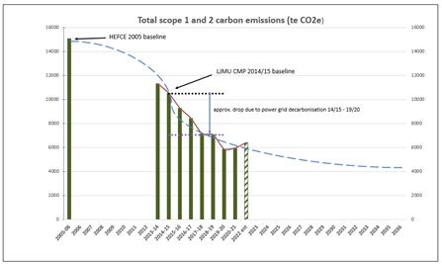We record and trend our major resource usages and calculate our CO2 emissions from our energy usage (Scope 1 and 2 emissions) against baselines and where we may be by 2035. We have done well over the last few years, but now significant decarbonisation of our infrastructure is being planned for so that we may achieve net zero carbon status by 2035.

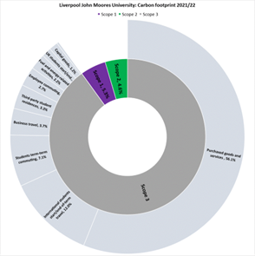

We have put in place systems and recording arrangements to allow us to calculate our carbon footprint, including scope 3 emissions from upstream and downstream components, which make up 90% of our total carbon footprint. Of our scope 3 emissions purchased goods and services, international student travel and student term time commuting contribute 75%.

Trend graphs and narrative for our main resource indicators are given in Appendix 4 - such as for water usage.

During academic years 2018/2019 and 2019/2020 the Covid pandemic affected the operations of the university, but the resource trends are now returning to normal.

This year’s data showed a decrease in overall energy usage – with a slight increase in electricity but a big drop in gas consumption. A hotter summer for which more cooling was required and increased operational work in some of our larger buildings increased the electrical demand from the previous year. Despite a colder winter necessitating more heating, gas demand reduced due to improved operational control, shortened opening hours in some buildings and active energy management.

# 6. **Active and Sustainable Travel Plan**

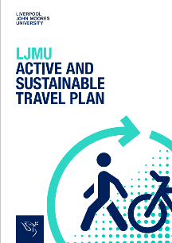Our [Active and Sustainable Travel Plan](https://www.ljmu.ac.uk/~/media/files/ljmu/about-us/climate-action/ljmu-travel-plan-october-2021-v2-(1).pdf?la=en), which aligns with the declaration of a climate emergency by the university in February 2020, requires a renewed focus on providing low carbon and carbon neutral travel options. It reflects our key role in the Liverpool City Region of advocating for and supporting the delivery of a healthier and more sustainable travel infrastructure.

The plan was created in consultation with our students and staff and will bring positive individual and shared benefits. Allowing cycling staff to claim a tax-free mileage allowance for university business (currently 26p/mile) is seen as a significant move away from car-centred benefits. This is backed by plans to extend changing and showering facilities on all campuses.

The [**‘**Smart Green Journey](https://www.ljmu.ac.uk/about-us/news/articles/2021/10/20/new-app-can-help-save-100-a-month-in-travel-costs)’ app has been developed with the backing of Metro Mayor Steve Rotheram and aims to encourage people to take more journeys by walking and cycling by telling you exactly how much money and carbon you save per journey every time you leave the car at home.

The free mobile app, available on Apple and Android devices, is one of the only ones available that outlines both the carbon and cost savings people can make by travelling more actively.

# **Appendix 1 – Progress on Priorities 2022/2023**

## **Environmental Management and Sustainability Action Plan 2022/2023**

**Status key:**

| **RED** | KPI not met |
| --- | --- |
| **AMBER** | KPI currently not on track to complete by the target date |
| **GREEN** | KPI completed or on track to complete by the target date |
| **GREY** | Work yet to begin |

| KPI | Required actions | Target date | Status | Comments |
| --- | --- | --- | --- | --- |
| To fulfil our environmental management compliance duties:  We will undertake a Duty of Care audit of our waste contractor | 1. Plan audit 2. Undertake audit 3. Report findings to Environmental Management and Sustainability Panel | June 2023 |  | A Duty of Care audit of the university’s waste contractor (B&M) was planned to be undertaken by the end of the academic year (this would have involved following the collection vehicle to the treatment facility where the waste is processed). This has not been completed. The action is to be rolled up into waste audit arrangements with Campus Services in 2023/2024 to avoid duplication. |
| We will operate an Environmental Management System (EMS):  We will define our target Environmental Objectives and set associated key performance indicators considering the university’s significant environmental aspects and compliance obligations | 1. Undertake engagement on draft Environmental Objectives (EOs), and associated key performance indicators (KPIs) 2. Finalise EOs and KPIs 3. Publish EOs and KPIs on the website and for the annual Environmental and Sustainability Report | August 2023 |  | We have worked on defining our target Environmental Objectives and setting associated key performance indicators considering the university’s significant environmental aspects and compliance obligations. Some objectives and KPIs are contained within the university’s Climate Action Plan while others are being included in the Carbon Management Plan, which is due for approval in December 2023. |
| Ensuring comprehensive and effective processes:  We will revise no.4 Environmental Codes of Practice (ECPs) for presentation to the Environmental Management and Sustainability Panel:   * ECP1 (Organisation for the implementation of the Environment and Sustainability policy) * ECP2 (Arrangements for the Implementation of the Environment and Sustainability Policy) * ECP4 Municipal Recyclable and General Waste Management * ECP5 Hazardous and Offensive Waste | 1. Revise and consult on draft ECPs 2. Amend with comments received as appropriate 3. Submit to last Environmental Management and Sustainability Panel meeting of the academic year | Last Panel meeting ~ June 2023 |  | We had programmed a review of several Environmental Codes of Practice. These are at various stages of revision while the higher priority Environmental Management, Energy Management and Sustainability Policy Statement has been reviewed and provided for approval by the Executive Leadership Team. |
| We will operate an Environmental Management System (EMS):   * EcoCampus Silver Award obtained | 1. Consult with Environmental Management and Sustainability Panel 2. Hold review meetings with EcoCampus 3. Consult with Faculties and Directorates 4. Submission to EcoCampus – draft 6th June and final 15th Aug 2023 | August 2023 |  | The university currently has the EcoCampus Bronze Award. Ninety percent of the work involved in obtaining the Silver Award involves Estates Development and Campus Services; to that end, in agreement with EcoCampus, the scope has been limited to the activities of those Departments.  Early in 2022/2203 it was decided to aim for the revised target date of December 2023 to include staff who would be involved in summer engineering works. Work has progressed on the Compliance Register and on the Environmental Aspects and Impact Register. |
| Being open and transparent about our environmental impact:  We will set up monitoring processes for resource usage covering 90% of university’s scope 3 emissions for inclusion in the annual Environment and Sustainability report. | 1. Engage with stakeholders to decide on range of potential scope 3 metrics 2. Set up data collection and assessment process 3. Publish scope 3 values on the website and for the annual Environmental Management and Sustainability Report | Completed end August 2023. |  | We have developed monitoring processes for the university’s scope 3 carbon emissions (these are indirect emissions that occur in the upstream and downstream activities of an organisation).  An external contractor has supported our approach to improve recording of our scope 3 emissions data – especially the two big issues of procurement and student accommodation. We will continue to account for the university’s scope 3 emissions in this annual report going forward – see section 5.1 and appendix 5. |
| To enhance our Environmental, Social and Governance (ESG) arrangements:  We will implement an improvement programme to increase our score for the People and Planet 2023 League Table | 1. Review 2022 scores 2. Identify improvement actions against scoring criteria 3. Identify and engage with action owners 4. Estimate potential 2023 league table score | Completed end August 2023. |  | As part of an improvement programme to increase our score for the People and Planet 2023 League Table, the Safety, Health and Environment Department has provided work experience for one of our students, who has worked with theme leads, for example the Head of Catering in respect of sustainable food.  Scoring for the league table takes place between July – August 2023, with the results published in December 2023.  A gap analysis was undertaken and areas for score improvement identified – tasks which included work experience for one of our students. Unfortunately, two main items (Sustainable Food Policy and Carbon Management Plan) were unable to be completed by the external scoring timetable.  However, our own marking indicates that the score against the People and Planet criteria has increased, albeit the league position is relative against others’ performance. |

# **Appendix 2 – Priorities 2023/2024**

## **Environmental Management and Sustainability Action Plan 2023/2024**

| No. | Principle | KPI | Required actions | Target date |
| --- | --- | --- | --- | --- |
| 1 | ESP 5 (resources) | We will provide appropriate resources:  We will have a formal handover of work plans to the new Sustainability Project Manager and the Environmental Sustainability Co-ordinator | 1. Recruit the Sustainability Project Manager ~ January 2024 2. Hold meeting to formal handover of work plans 3. Recruit the Environmental Sustainability Co-ordinator ~ March 2024 4. Hold meeting to formal handover of work plans | February and April 2024 |
| 2 | ESP 11 (audit) | To fulfil our environmental management compliance duties:  We will undertake a Duty of Care audit of our waste contractor | 1. Plan audit as part of the Safety, Health and Environment and Campus Services joined up waste audit schedule arrangements 2. Undertake audit 3. Report findings to Environmental Management and Sustainability Panel | Last Panel meeting ~ June / July 2024 |
| 3 | ESP 8  (EMS) | We will operate an Environmental Management System (EMS):   * EcoCampus Silver Award obtained | 1. Consult with Environmental Management and Sustainability Panel 2. Hold review meetings with EcoCampus 3. Consult with Campus Services and Estate Development 4. Submission to EcoCampus | January 2024 |
| ~~4~~ | ESP 10 (standards) | To enhance our Environmental, Social and Governance (ESG) arrangements:  We will implement an improvement programme to increase our score for the People and Planet 2023 League Table. | 1. Review 2023 scores 2. Identify improvement actions against scoring criteria 3. Identify and engage with action owners 4. Ensure the Sustainable Food Policy and Carbon Management Plan are published on the website 5. Estimate potential 2024 league table score | August 2024 |

# **Appendix 3**

## **Examples of LJMU published news articles on Environmental Management and Sustainability issues**

| **Date** | **Story** |
| --- | --- |
| 13 October 2022 | Climate Action Plan video:  Leadership - [Climate Action Plan - Leadership - YouTube](https://www.youtube.com/watch?v=JistRD8U4qk) |
| 17 October 2022 | [New 'low carbon' cement idea wins international engineering prize](https://www.ljmu.ac.uk/about-us/news/articles/2022/10/17/construction-award-ice?utm_campaign=2230190_Staff%20Newsletter%2020%20October%202022&utm_medium=dotmailer&utm_source=email%20marketing&dm_i=2SCX,1BSTQ,8A7BNU,56Q3Y,1) |
| 27 October 2022 | Climate Action Plan video:  Teaching - [Climate Action Plan - Teaching - YouTube](https://www.youtube.com/watch?v=E44gC8D2VHs) |
| 20 October 2022 | Climate Action Plan video:  Research - [Climate Action Plan - Research - YouTube](https://www.youtube.com/watch?v=7N2VJktG2V0) |
| 21 October 2021 | [1823 Podcast: Season 4 Episode 4: the road to net zero](https://www.ljmu.ac.uk/podcast) |
| 28 October 2022 | [Rapidly changing climate poses high risk for legacy waste pollution on UK coast](https://www.ljmu.ac.uk/about-us/news/articles/2022/10/28/rapidly-changing-climate-poses-high-risk-for-legacy-waste-pollution-on-uk-coast) |
| 1 November 2022 | [Heating engineer wins Undergraduate of Year Award](https://www.ljmu.ac.uk/about-us/news/articles/2022/11/1/bas-pilar?utm_campaign=2238728_Staff%20Newsletter%203%20November%202022&utm_medium=dotmailer&utm_source=email%20marketing&dm_i=2SCX,1BZEW,8A7BNU,57JBQ,1) |
| 3 November 2022 | Climate Action Plan video:  Community Engagement - [Climate Action Plan - Community Engagement - YouTube](https://www.youtube.com/watch?v=ZVl9pubeMEQ) |
| 10 November 2022 | Climate Action Plan video:  Campus Management - [Climate Action Plan - Campus Management - YouTube](https://www.youtube.com/watch?v=gtv0vNyGz0I) |
| 18 November 2022 | [Impact: LJMU low carbon centre showcases best university practice](https://www.ljmu.ac.uk/about-us/news/articles/2022/11/18/lowcarbonei-at-oecd) |
| 8 December 22 | [LJMU rated highly in sustainability table](https://www.ljmu.ac.uk/about-us/news/articles/2022/12/8/ljmu-rated-highly-in-sustainability-table?utm_campaign=2259693_Staff%20Newsletter%208%20December%202022&utm_medium=dotmailer&utm_source=email%20marketing&dm_i=2SCX,1CFL9,8A7BNU,59IFD,1) |
| 12 December 22 | [LJMU launches cost of living hub to support students](https://www.ljmu.ac.uk/about-us/news/articles/2022/12/12/ljmu-launches-cost-of-living-hub-to-support-students) |
| 14 December 2022 | [LJMU helps schoolchildren learn about the environment](https://www.ljmu.ac.uk/about-us/news/articles/2022/12/14/ljmu-helps-schoolchildren-learn-about-the-environment) |
| 5 January 2023 | [PFAS: you can’t smell, see or taste these chemicals, but they are everywhere – and they’re highly toxic to humans](https://www.ljmu.ac.uk/about-us/news/articles/2023/1/5/the-conversation-pfas-patrick-byrne) |
| 11 January 2023 | [Saving energy on campus](https://www.ljmu.ac.uk/about-us/news/articles/2023/1/11/saving-energy-on-campus) |
| 25 January 2023 | [Developing sustainable rail and seaport infrastructure with Malaysian universities](https://www.ljmu.ac.uk/about-us/news/articles/2023/1/25/developing-sustainable-rail-and-seaport-infrastructure-with-malaysian-universities) |
| 25 January 2023 | [LJMU to set out plans for estate developments](https://www.ljmu.ac.uk/about-us/news/articles/2023/1/25/ljmu-to-set-out-plans-for-estate-developments?utm_campaign=2283041_Staff%20Newsletter%2026%20January%202023&utm_medium=dotmailer&utm_source=email%20marketing&dm_i=2SCX,1CXLT,8A7BNU,5BM57,1) |
| 31 January 2023 | [LJMU technology to revolutionise sustainable road building](https://www.ljmu.ac.uk/about-us/news/articles/2023/1/31/ljmu-technology-to-revolutionise-road-building) |
| 6 February 2023 | [Embedding nature in local planning](https://www.ljmu.ac.uk/about-us/news/articles/2023/2/6/embedding-nature-in-local-planning) |
| 9 February 2023 | [Eco coastal defence technology wins LCR Launchpad](https://www.ljmu.ac.uk/about-us/news/articles/2023/2/9/eco-coastal-defence-technology-wins-lcr-launchpad) |
| 15 February 2023 | [Engineers to develop new electric-hydrogen ships](https://www.ljmu.ac.uk/about-us/news/articles/2023/2/15/electric-ships) |
| 2 March 2023 | [Brick making technology using construction wastes wins UKRI circular economy fund](https://www.ljmu.ac.uk/about-us/news/articles/2023/3/2/cccltd) |
| 6 March 2023 | [Opportunities for veterans to plug skills shortage in green energy sector](https://www.ljmu.ac.uk/about-us/news/articles/2023/3/6/opportunities-for-veterans-to-plug-skills-shortage-in-green-energy-sector) |
| 8 March 2023 | [Business School leads sustainability teaching innovation and research](https://www.ljmu.ac.uk/about-us/news/articles/2023/3/8/business-schools-leads-sustainability-teaching-innovation-and-research) |
| 14 March 2023 | [Report on benefits of outdoors debated in Scottish Parliament](https://www.ljmu.ac.uk/about-us/news/articles/2023/3/14/camping) |
| 30 March 2023 | [Green Careers and Insights Fair](https://careerszone247.careercentre.me/resources/newsroom/newsroom.aspx?newsid=22394) |
| 30 March 2023 | [The Big Sustainability Challenge](https://careerszone247.careercentre.me/resources/newsroom/newsroom.aspx?newsid=22393&redirectUrl=/Newsroom/Home/News/22393) |
| 12 March 2023 | [Business education drives social and environmental change](https://www.ljmu.ac.uk/about-us/news/articles/2023/4/12/business-education-impact) |
| 12 March 2023 | [Geopolymer offers hope for low carbon constructors of future](https://www.ljmu.ac.uk/about-us/news/articles/2023/4/12/novel-composite-concrete) |
| 20 April 2023 | [Geographers say sterile gardens raise risk of flooding](https://www.ljmu.ac.uk/about-us/news/articles/2023/4/20/sterile-gardens) |
| 3 May 2023 | [Greening up our campus](https://www.ljmu.ac.uk/about-us/news/articles/2023/5/3/greening-up-our-campus) |
| 12 May 2023 | [Zenova partnership for energy efficient homes](https://www.ljmu.ac.uk/about-us/news/articles/2023/5/12/zenova-partnership-on-homes) |
| 10 July 2023 | [Climate Change generation celebrate Graduation](https://www.ljmu.ac.uk/about-us/news/articles/2023/7/10/climate-change) |
| 29 August 2023 | [Get 'Too Good to Go' food from Core Cafes](https://www.ljmu.ac.uk/about-us/news/articles/2023/8/29/download-too-good-to-go?utm_campaign=2371006_Staff%20Newsletter%2031%20August%202023&utm_medium=dotmailer&utm_source=email%20marketing&dm_i=2SCX,1ETHA,8A7BNU,5KOAX,1) |

# **Appendix 4 – Resource trends**

|  |  |
| --- | --- |
| For 2022/2023 the data showed a decrease in overall energy usage driven by a slight increase in electricity but a big drop in gas consumption. An effective Christmas shutdown procedure and proactive monitoring by our Energy Manager to identify issues early also helped to reduce energy wastage. |  |
| With a hotter summer requiring more cooling across the university and increased operational work in some of our larger buildings, electrical usage increased from the previous year. Also, during refurbishment work, gas boilers have been replaced with electrical heating resulting in a greater demand.  Despite a colder winter necessitating more heating, gas demand reduced due to improved operational control, shortened opening hours in some buildings and active energy management. |  |
| The university continues to install water saving measures during refurbishment and for new buildings. The intensity ratio of water usage by both per square meter of floor area for universities and colleges(1) and per person per year for offices(2) puts us in the ‘best practice’ range. |  |
| (1) [Environment Agency Typical and Best Practice Benchmarks](https://webarchive.nationalarchives.gov.uk/ukgwa/20140328222606/http:/www.environment-agency.gov.uk/business/topics/water/34866.aspx)  (2) [CIRIA C657 Water Key Performance Indicators and Benchmarks for Offices and Hotels](https://www.waterwise.org.uk/wp-content/uploads/2018/02/CIRIA-2006_Water-Key-Performance-Indicators-and-Benchmarks-for-Offices-and-Hotels.pdf) | |

|  |  |
| --- | --- |
| Carbon emissions are a way of reporting greenhouse gas releases to the environment. Scope 1 emissions are those under direct control of an organisation such as fuel combustion by gas boilers and fleet vehicles. Scope 2 emissions are indirect emissions such as from electricity purchased and used by the organisation. | |
| The graph below is our longer-termcarbon emission (Scopes 1 and 2) trend. It shows our Scope 1 and Scope 2 emissions are lowering. In the past a significant proportion of the drop in emissions was due externally to the decarbonisation of the national grid energy supply. Our future energy decarbonisation plans should reduce our emissions going forwards towards 2035. | |
|  | |
| This graph shows the amount of waste disposed of and the amount recycled. The recycling rate is now at 62%, although we are still taking steps to reduce the total amount of waste produced. |  |

# **Appendix 5 Carbon Footprint**

The university aims to capture and understand information on its scope 3 emissions and to be consistent and transparent in its reporting. To do this we have set up a robust approach to data capture which can be used year on year, and which aligns with the sector’s standard framework.

The [Standardised Carbon Emissions Framework for Further and Higher Education (SCEF)](https://www.eauc.org.uk/file_uploads/standardised_carbon_emissions_reporting_-_methodology_guidance_-_version_3_0_-_01_12_22.pdf) was developed by EAUC (the Alliance for Sustainability Leadership in Education) in consultation with the Platinum Jubilee Challenge participants and the education sector via member bodies, including the Association of Colleges (AoC), Colleges Scotland and Universities UK (UUK). The framework brings together good practice and guidance and will develop a fuller understanding of how institutions contribute to the climate emergency and enable them to act.

The university has used values from either our Higher Education Statistics Agency (HESA) submission, the Higher Education Supply Chain Emissions Tool (HESCET) to convert financial spend to supplier emission data, or calculations from internal data using the SCEF framework, to calculate our total carbon footprint, as represented below.

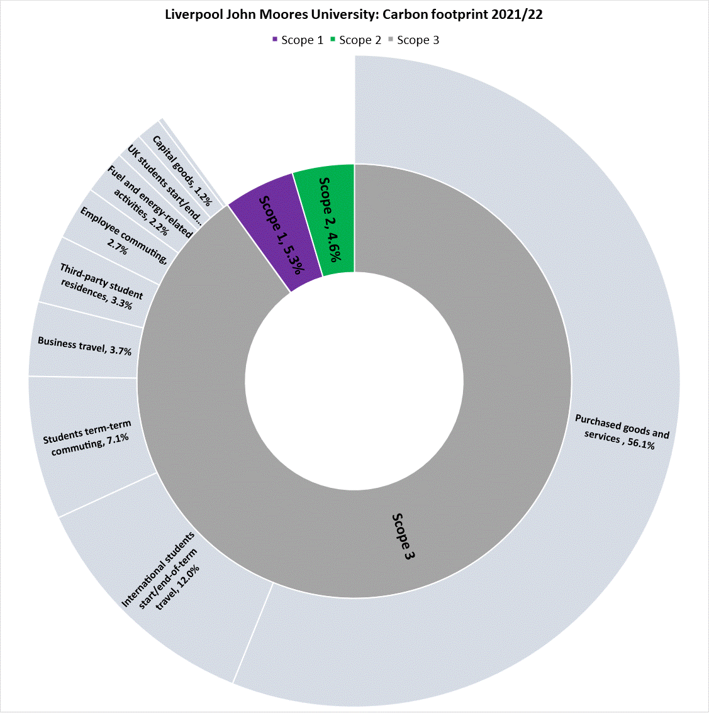

Having baselined our emissions, we will track our trend over time as we take steps to reduce our carbon footprint.

