Research Informed Teaching:
The observation of planets with the Liverpool Telescope: what does ‘Earth-like’ mean?
General Context
One of the most active areas in modern astrophysics is the discovery and characterisation of exoplanets: planets which orbit stars other than our own Sun. The planets can usually not be imaged directly, but their presence can be inferred via their effect on the light from the star. Increasing our understanding of the parameters of exoplanets is a primary goal of major new facilities such as NASA’s James Webb Space Telescope (JWST), but this is also a topic which is well matched to the interests of the Time Domain group at the Astrophysics Research Institute, and with the Liverpool Telescope we have our own powerful tool for studies of this type.
Specific Project Work (200 words)
The presence of planets can be inferred observationally via a number of methods, but one of the most powerful techniques is the transit method, in which tiny dips in the brightness of the star are measured as the planet passes across the stellar disc (Figure 1). This reveals a wealth of information about the planet. For example, its size can be inferred from the size of the dip. Such observations need to be timed to take place at the exact time when the star, planet and observer align, and so the flexible scheduling capabilities of a robotic telescope like the Liverpool Telescope makes it an ideal tool for this task. The Liverpool Telescope has a long history in this field, but a recent high-profile project was its key contribution to the characterisation of the TRAPPIST-1 system¹. This star was found via the transit method to host a system of seven planets (Figure 2). It was further determined that all seven of these planets are approximately Earth sized, and crucially three of the planets lie in the so-called `habitable zone’ in which the temperature of the planets may be conducive to liquid water on their surfaces. By comparison the vast majority of the known exoplanet population consists of bodies that are much larger, Jupiter-like gas giants; and also much hotter. The TRAPPIST-1 planets are therefore primary candidates in the search for extrasolar life, and one of the most exciting goals of JWST will be to attempt to measure the composition of the atmospheres of these planets and other such candidates. Study of this system with the Liverpool Telescope have continued, with Dr. Amaury Triaud from the University of Birmingham observing transits with the aim of detecting tiny time shifts due to the gravitational influence of the planets on each other. This enables further refinement of the planetary parameters.
Impact on curriculum (300 words) which course or modules changed, what changes occurred, link to specific students (delivery) or content
Given that we have built up over the years a large archive of Liverpool Telescope observations of exoplanetary transits, there was an opportunity to take a data-driven approach to understanding this subject within the PHYS355: Planetary Physics module on our undergraduate programmes. A practical workshop has been developed as part of this module in which students attempt to determine planetary parameters from real transit data. This investigation is open ended since there is a wide range of measurements which can be made from a single dataset, and more advanced students can approach aspects of the task such as error analysis in greater detail. This component of this module builds on observational and data analysis techniques introduced in the Practical Astrophysics modules, and also links well with our goal in recent years of developing (Python) computer programming ability throughout our undergraduate programmes.
Secondly, we draw on the TRAPPIST-1 system as a case study for the discussion session in the PHYS355 module on the subject of the search for Earth-like planets. It is increasingly understood that ‘Earth-sized and in the habitable zone’ is only the first step in describing a planet as ‘Earth-like’ and the peculiarities of the TRAPPIST-1 system make it a very useful example for the exploration of this topic. For example, the star in this system is very different to the Sun, and concentrated X-ray radiation from the star might hinder planetary atmosphere formation. The orbital dynamics in the system might also be very different to the Earth and Sun. Of course, the main reason why we are interested in Earth-like planets is that they are potential homes to extrasolar life. The TRAPPIST-1 star is faint and red, and some recent research² has proposed that such stars might not produce enough of the ultraviolet radiation which is necessary for the photochemistry necessary for the formation of the first amino acids. This discussion concludes with a look at the new observational facilities and techniques which will address these questions with the next couple of decades. These topics transcend astrophysics as subjects of universal human interest, and as such they tend to be the most popular parts of the module as measured from student feedback.
Some example quotes from the 2022 anonymous feedback:
“...the balance between ‘understood’ and ‘known stuff’ compared to what is unknown and still developing keeps the topic alive and makes it very interesting.”
“...the lectures renewed my interest in astrophysics that I lost after A-level… I find the questions challenging but interesting’.
Broader Change (300 words) did curriculum impact lead to change in skills, career choice and employability, student evaluation, other impacts (advertising case studies, alumni lectures)
The Liverpool Telescope is a well-utilised resource for both public engagement (via the National Schools Observatory) and the ARI’s world-leading research programmes. It does however have some untapped potential as a tool for undergraduate teaching. There is the potential to incorporate telescope data into more modules, and the PHYS355 example serves as a testbed for such expansion. Perhaps more exciting is the opportunity to expand the number of students who are directly involved in data collection using the telescope. Typically, a number of students on our teaching programmes use the telescope, collecting and analysing their own data, as part of their final year research projects. The fact that the robotic telescope can be accessed from anywhere in the world makes this particularly well suited to our taught Distance Learning programmes. One of the main limiting factors we have on expansion of the DL programmes in particular is the amount of staff time required to supervise these projects, since each student is assigned a unique project. However, we developed and are now trialling a new approach to projects in which a group of students can be supervised simultaneously (or multiple staff will supervise the same group at different stages). The general idea is that a large group of students will be given the same broad and open-ended goal (such as the transit investigation discussed here) and can be trained in groups with the same data analysis techniques, but will make their observations independently and so will have their own (hopefully, publishable) dataset to work with. The scope for expanding student participation in data collection will increases even further later in this decade when the New Robotic Telescope begins science operations.
References
- Gillon M., Triaud A.H.M.J., Demory B., Jehin E., Agol E., Deck K.M., Lederer S.M., de Wit J., Burdanov A., Ingalls J.G., Bolmont E., Leconte J., Raymond S.N., Selsis F., Turbet M., Barkaoui K., Burgasser A., Burleigh M.R., Carey S.J., Chaushev A., Copperwheat C.M., Delrez L., Fernandes C.S., Holdsworth D.L., Kotze E.J., Ven Grootel V., Almleaky Y., Benkhaldoun Z., Magain P., Queloz D., 2017, Nature, 542, 456
- Rimmer P.B., Zu J., Thompson S.J., Gillen E., Sutherland J.D., Queloz D., 2018, Science Advances, 4, 8
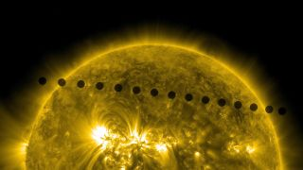
Fig 1. A composite image showing Venus as it transits across the disc of the Sun, as seen by NASA’s Solar Dynamics Observatory. (Credit: NASA/SDOP, HMI)

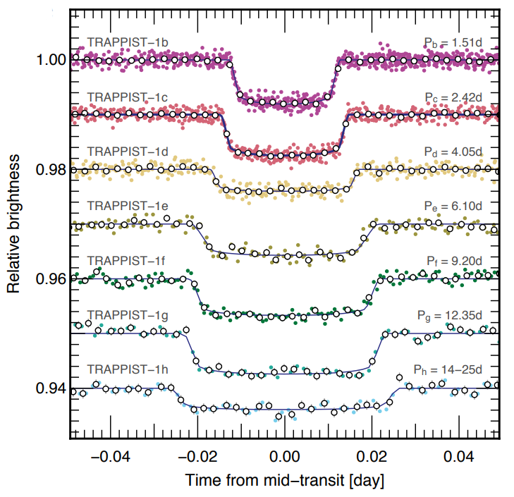
Fig. 2. Dips in brightness of the TRAPPIST-1 star caused by the transits of the seven planets across the stellar disc. The unique shapes of each transit allow us to differentiate the planets from each other, and through modelling we can infer the parameters of the planets¹

