From Paper to Podium: Performing Sport Nutrition Research in the Curriculum that directly influences athletic performance and educates the next generation of sport nutritionists.

General Context. Sport Nutrition has been a long-standing area of expertise within The School of Sport and Exercise Sciences at Liverpool John Moores University. Over the past decade, there has been a major focus on performing sport nutrition research that has immediate translational potential in the areas of team, weight-making, and endurance sports. This has coincided with the development of the MSc in Sport Nutrition at LJMU, which is SENr accredited and aimed at providing a direct pathway into employment for our graduates in the sport nutrition industry. Our research was a major contributor to setting up the MSc programme and continues to infuse the curriculum. The curriculum is current and answering real world problems that have come from our experiences researching and consulting in professional sport. Moreover, our paper entitled “Paper to Podium: Evaluating the translational potential of sport nutrition research” (Close, Kasper, & Morton, 2019) which was co-authored by a JMU MSc Sport Nutrition student (Kasper) is used to structure the students learning and is an integral part of their academic learning.

Specific Project Work. There are numerous examples of where the applied research from the sport nutrition group directly influences the curriculum and applied sport. Specifically, over the past decade Professor Close has developed a research team who work at the interface between applied sport and sport nutrition research and contribute to taught courses. This has included Daniel Owens (internally funded on Vitamin D and athletic performance), Richard Alison (funded by Aspetar, Qatar on Vitamin D and Cardiac Function), George Wilson (nutrition for weight-making in jockeys funded by Abu Dhabi and The British Horseracing Association), Jamie Pugh (funded by industry and the MRC on probiotics and the athletes gut), Scott Gillham (funded by industry on cannabinoids and the athletes), Andy Kasper (funded by the Rugby Football Union on developing the paper to podium model), James Hudson (funded by Gloucester Rugby on the nutritional demands of rugby damage), James Morehen (funded by Warrington Wolves on metabolic demands of elite rugby) and many more. Collectively, this research has had a major influence on both the undergraduate and MSc curriculum at LJMU including modules such as “Fundamental sport nutrition”, “Applied sport nutrition” as well as “Drugs and supplements in sport”, that are directly linked to our applied PhD research. Moreover, this work has been covered extensively in key texts such as Science and Football and Science and Rugby which are core texts for many LJMU modules. The work has not only been instrumental in the teaching at LJMU and beyond but has also resulted in major policy changes in sport and even resulted in rule changes in some sports whilst at the same time, providing knowledge and craft skills for our students and a route to graduate employment.

Impact on curriculum. The applied sport nutrition research from LJMU has not only influenced the curriculum but has indeed resulted in a specific MSc programme being developed largely based on the groups research. This SENr accredited degree programme has quickly become the world leading MSc in Sport Nutrition with The EIS describing this programme as “a production line for nutrition talent within the UK” (Nigel Mitchell, Technical Lead, The English and Welsh Institutes for Sport). The programme continually recruits above target with students coming from around the world (including Europe, India, Thailand, USA, Africa and many more) to study at LJMU. The students are initially taught the paper to podium framework that we developed and published showing how to evaluate and perform applied sports nutrition research and then get the opportunity to perform such research as part of their dissertation. Many key papers that have advanced knowledge in applied sport nutrition has come from MSc Sport Nutrition dissertation projects including our evaluation of using food photography to assess dietary intake in athletes (Reuben Stables) and assessing the prevalence of cannabidiol use in sport and reasons why (Andreas Kasper). Our students then go on a work placement in professional sport (including Premier League football clubs, Super League rugby, International rugby, The FA, The EIS and Industry) which allows them to translate this research into applied practice. It is a direct result of this innovative research informed teaching and applied placement that we now have a huge track record of our students gaining employment in professional sports with current graduates working for The Football Association (James Morehen), The Rugby Football Union (Andreas Kasper), Scottish Rugby Football Union (Antonia Roach), Premier League Football (Reuben Stables, Hannah Mayho, Andreas Kasper, Aimee O’Keefe), The Lawn Tennis Association (Dan Ellis), Qatar FA (Marcus Hannon), The English Institute of Sport (James Moran), The DP World Tour Golf (Amy O’Donnell), The German Ski Federation and many more elite organisations. We have also generated some amazing work opportunities for our students whilst on placement that has then resulted in paid employment for example Amy O’Donnell attending The Solheim Cup in The USA with Team Europe (golf) and Sophie Hannon attending the 2023 Womens Rugby World Cup in New Zealand.
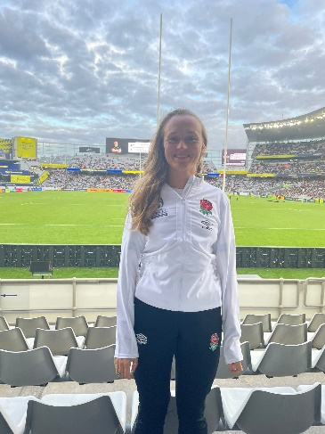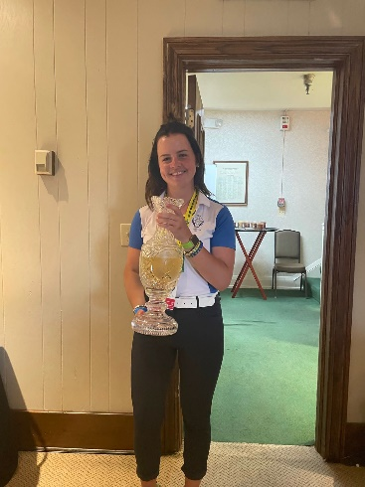

Left – Sophie Hannon at the 2023 World Cup in New Zealand delivering Nutrition support and right Amy O’Donnell at the 2022 Solheim Cup in USA delivering nutrition support to Team Europe. Both were students at the time on the LJMU MSc Sport Nutrition implementing our research informed teaching.

Broader Change.
The MSc Sport Nutrition has consistently received outstanding feedback on the PTES evaluation with some years reporting 100% satisfaction and never worse than 96%. We have had multiple examples of students coming to us looking for a career change and landing their dream roles in sports directly from the programme.
“Prior to completing the Sports Nutrition MSc at LJMU I was working as a Dietitian in the NHS. I would not have been able to work in my current roles without going to LJMU to do the MSc in sports nutrition. What sets the MSc course at LJMU apart from other universities is the fact it is taught by lecturers who also work in professional sport; so the teaching is informed by research and practical, applied knowledge”. Hannah Mayho – Sport Dietician Manchester City
Many of our students are choosing our programme because of its reputation of placing students on placements which has a major influence on their future career. There are numerous examples of this, including lectures from other institutes recommending our MSc to their students to help them on their career, for example Marcus Hannon was recommended to join us and since working at LJMU Marcus has held roles at Everton FC, Aston Villa and now heads up sport nutrition for the Qatar FA.

In summary, the MSc in Sport Nutrition from LJMU has changed the face of sport nutrition programme delivery, curriculum content, student experience and employability opportunities not only in the UK but across the globe. Described as a “production line for talent in the sport nutrition industry”, it is the combination of research informed teaching, experience of the lectures from applied sport, innovative research performed by our students and the applied placement that has cemented this course as the world leading programme in sport nutrition with an enviable track record of gaining student employment as well as developing future academic leaders (e.g. Rob Seabourne, Daniel Owens and many have progressed from the MSc to hold prominent academic roles in leasing universities). It really is a life changing programme.

References
Close, G. L., Kasper, A. M., & Morton, J. P. (2019). From Paper to Podium: Quantifying the Translational Potential of Performance Nutrition Research. Sports Med, 49(Suppl 1), 25-37. doi:10.1007/s40279-018-1005-2

