School of Civil Engineering and Built Environment
Research Informed Teaching:
The application of analytical techniques to understand materials at micro molecular level.
The inclusion and development of analytical characterisation skill in the Core Materials Module to explain the relation between the physico-chemical structure of the construction material and its properties to prepare students for research and critical analysis.
General Context
Materials is one of the three core modules required to be taught in the Civil Engineering BEng and MEng program that is specified by the UK Engineering Council and Accrediting authority (JBM).The JBM also requires that sustainable development be integrated into existing teaching and learning and should clearly feature throughout the education programme. Through this learning students will understand that their interventions should minimise the temporary borrowing of finite-resource material, while maximising societal benefit. To ensure this, the following two key learning outcomes were embedded in the level 5 Materials module (5200CIV) across the board of all BEng and MEng accredited programmes at LJMU:
- Evaluate how a material’s manufacture, treatment alters its microscale and macroscale properties and be able to broadly predict a material’s behaviour from microscale inspection.
- Demonstrate an understanding of novel and innovative construction materials and their applications.
Specific Project Work
Dr Monower Sadique’s Doctoral study and funded research in Low Carbon Construction Materials within the Built Environment & Sustainable Technologies (BEST) Research Institute are focused on developing Concrete, Ceramics, Geopolymer and Asphalt product with low embodied carbon using wastes generated form foundation industries (cement, glass, paper, chemical and metal). The development and production of new low carbon materials requires advanced analytical characterisation to explain the relation between the physico-chemical structure of the material and its properties. Integrated microelectronic structure analysis of surfaces with laser beams and x-ray fluorescence aided devices are found to be helpful for analysing substances at micro and molecular level. In addition to characterisation, they also provide important information, including interrelationships amongst physical, chemical, mechanical and durability characteristics of the developed products. Hence, Dr Sadique embedded, and taught, the introductory application of analytical analysis of construction materials using EDXRF, XRD, SEM in this level 5 module to prepare them to undertake individual research for dissertation and design modules in next level (Level 6 and 7) of study. In collaboration with LJMU PBS, Dr Sadique has successfully supervised and trained as lead supervisor four PhD researchers (completed between 2021 2023). Out of these four PhD students, three students were LJMU graduates who completed their BEng and/or MSc here at LJMU. In this PhD research on construction materials, analytical techniques were extensively applied and enriched the research quality. These Doctoral research projects have also generated three patents which are under the filling/examination stage by LJMU RIS. One of the scientific papers generated from these researches using analytical techniques won Advances in Cement Research Prize - 2022 ICE Publishing Awards, Institution of Civil Engineers (ICE) [1].

The volume of our collaborative research projects with partners overseas (Bangladesh, India, and Iraq) in the Materials and Civil Engineering field has also been influenced through these activities.
Impact on curriculum
Civil Engineering Materials is taught at all levels. The modules involve learning key construction materials used in civil engineering. Based on Dr Sadique’s industry experience and research and knowledge exchange activities [2,3], he teaches the students how to select the relevant material to be used based on their properties, cost and on their embodied carbon. Also, by introducing the aspects of the research projects (from India [4] & Bangladesh [5]) to students this widens their appreciation of the global construction industry and the differing practices around the world in addition to ensuring inclusive learning, teaching and research attitude and culture to enable students to develop their full potential and ultimately contribute to the challenges of the day. In collaboration with partner institution, samples of industrial wastes were collected from India and Bangladesh for the above industrial research project and tested them using analytical techniques for their potential application in developing cement-free concrete and clay-free unfired brick respectively.
Students are introduced to the advanced materials found during Dr Sadique’s research and are shown how to analyse new materials for their structural properties based on his pioneering collaboration with the LJMU School of Pharmacy and Bio-molecular science looking at advanced analytical investigation techniques using X-ray Diffraction (XRD), Energy Dispersive X-Ray Fluorescence (EDXRF), Scanning Electron Microscopy (SEM), Thermo Gravimetric Analysis (TG)A, Fourier Transform Infrared Spectrometer (FT-IR). Dr Sadique have embedded this multi-disciplinary approach in the teaching of Materials modules at UG/PG level improving student’s confidence and enriching students’ experiences of real-world issues. Graduating LJMU students are in an advantageous position having been introduced to these in-demand industry skills and knowledge which enhance their employability as well as LJMU’s reputation as an international centre of knowledge and expertise.
Dr Sadique embedded this multi-disciplinary approach in teaching Level 5 Materials module that enrich students’ experiences and opens a new horizon, which positioned both LJMU and the students involved at a highly positive stage within the industry and academia. The teams’ research-led and research-informed teaching in this module contribute to the continued development of an academic culture and sense of community within the school resulting in a solid proportion of UG and PG student taking on experimental research projects related to low carbon construction materials at Level 6 (6304DCIV/6304CIV). The dissertation module enables students to personally select, and complete an in-depth study on, a topic related to their degree specialism. The module develops students' practical research skills and enhances their knowledge and expertise in their degree specialism. As the completion of a dissertation is principally student-led the module offers the opportunity to further develop critical analysis of published works as well as potentially develop their own outputs. As a measure of impact; two UG research projects conducted under Dr Sadique’s supervision for 6304CIV have culminated in publications in international journals (Durrans et al. [6] & Strohle et al. [7]) where the students in question were the contributing authors.
Some example quotes from previous students’ feedback:
“Whilst undertaking the MSc Civil Engineering I completed important research under the guidance of Denise Lee, Monower Sadique and LJMU, the research was further published in an international journal.”
“...the lectures gave me numerous information on several analytical techniques for the construction materials such as XRF, XRD, FTIR, TGA and SEM… helped me to have a successful employment.”
Broader Change
The quality and evidence-based research supported by analytical analysis of construction materials at micro molecular level resulted in developing the “Eco-Brick” through GCRF 2019 & 2021 supporting global action on climate change, offered a solution to Bangladesh’s toxic brick industry. Clean brick manufacturing has become a key industrial priority since the Bangladeshi Government moved to outlaw highly polluting traditional brick making processes by 2023/24 in a bid to cut air pollution. The brick product was included in a structural demonstration in Bangladesh. The success of the brick product developed under Dr Sadique and his team at BEST attracted attention from policy makers, manufacturers, and development partners in Bangladesh. This meaningful contribution and recognition attracted positive impact with tangible benefits that resulted in Dr Sadique’s appointment as Visiting Professor at Chittagong University of Engineering and Technology (CUET), Bangladesh in 2021. The scientific paper using analytical techniques emerged from this research won Best Paper Award in the 5th International Conference on Civil Engineering for Sustainable Development: ICCESD 2020, Khulna, Bangladesh sponsored by ICE, UK [8] and published in international journal [9]
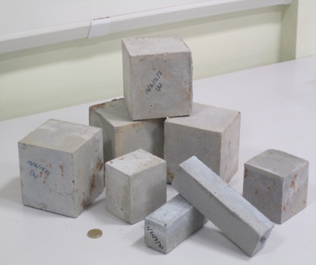
Fig 1: Cement-free Cementious binder developed by Dr Sadique at BEST
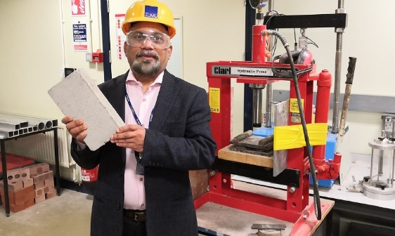
Fig 2: Dr Monower Sadique with unfired clay-free “Eco-Brick” for Bangladesh
References
[1] Advances in Cement Research Prize - 2022 ICE Publishing Awards, Institution of Civil Engineers (ICE), https://www.icevirtuallibrary.com/page/authors/awards-2022
[2] Exploring LJMU unfired brick patent using the waste generated in CD&E waste recycling plant at CCC Ltd and upscaling to brick manufacturing on site. Scheme: Innovate UK- Circular Economy for SMEs - innovating with The National Interdisciplinary Circular Economy Research (NICER), round 2. Partner: CCC Waste Ltd, Liverpool. £150k
[3] A novel cement-free concrete (GEOBLOCK) for breakwaters (coastal protection) through an industrial symbiosis of waste generated in LCR. Scheme: Innovate UK- Launchpad - Advanced Manufacturing - CR&D - Liverpool City Region. Partner: Virtus Concrete Solutions (VCS), Liverpool. £570k
[4] Developing Low carbon cement for decarbonising foundation industries by recycling CCR and other industrial waste available in the UK and India. Scheme: Innovate UK- Foundation Industries Lab to Lab India Collaboration. Partner: NIRMA University, India. £70k
[5] Performance evaluation of non-fired clay free brick - Introducing a clean brick manufacturing in Bangladesh. Scheme: GCRF. Partner: Chittagong University of Engineering and Technology (CUET), Bangladesh. £25k
[6] Strohle M, Sadique MM, Dulaimi AF, Kadhim MA. 2022. Prospect and barrier of 3D concrete: a systematic review Innovative Infrastructure Solutions, 8. https://link.springer.com/article/10.1007/s41062-022-00975-w
[7] Durrans D, Lee D, Sadique M. 2022. Application of concrete encased ecobrick blocks in the UK’s construction industry Kufa Journal of Engineering, 13 :70-89. https://journal.uokufa.edu.iq/index.php/kje/article/view/1848
[8] Best Paper Award, 5th International Conference on Civil Engineering for Sustainable Development: ICCESD 2020, Khulna, Bangladesh sponsored by ICE, UK., https://www.ice.org.uk/eventarchive/civil-engineering-sustainable-development-khulna
[9] Islam GMS, Sarker S, Sadique MM, Shubbar AAF. 2022. Non-Fired Building Blocks Using Industrial Wastes Journal of Engineering Science, 12 :1-10. Full article: Ternary combined industrial wastes for non-fired brick (tandfonline.com)

