# **Research-Informed Teaching case study: Mutual benefits for research, practice, policy and teaching in conservation translocations**

**Lead:** Dr Sarah Dalrymple

**Contributors:** Dr Lucia Galvez-Bravo, Dr Robert Fitt, Dr Luiza Figueiredo Passos, Dr Danni Hinchcliffe, Dr Stephanie Evers, Dr John Abernethy, Dr Christine Beardsworth

BSc Wildlife Conservation Programme Team, School of Biological and Environmental Sciences

**General Context**

Conservation translocations are the deliberate movement of plants, animals and fungi by humans to produce benefits for threatened species status and ecosystem restoration. Within the BSc Wildlife Conservation programme, we work across research, policy and practice spheres, and this has informed our teaching, facilitated student involvement in placements and research, and come full circle by feeding back into good practice in conservation translocations globally. We aim to provide our students with an understanding of conservation translocations that is nuanced, applied to the real world and interdisciplinary, and in doing so, we are training future conservationists equipped to deal with a complex world.

**Specific Project Work**

The work by the BSc Wildlife Conservation team at LJMU encompasses multiple projects that aim to improve the implementation of conservation translocations. Specific examples are detailed here but this is part of a broader portfolio of activities involving the whole team.

***Influencing decisions on translocation site selection***

Doctoral research by Joe Bellis (lead supervisor, Sarah Dalrymple) identified a robust relationship between poor climate suitability and translocation failure using a global dataset of past reintroductions (Bellis *et al.*, 2020); these methods were adapted to the local context at a number of sites within the Greater Manchester Wetlands (Bellis *et al.*, 2021).

***Monitoring of impacts of beaver releases using novel eDNA methods***

Also in North-West England, investigations led by Lucia Galvez Bravo, and including a number of PGR and undergraduate students, are currently developing novel monitoring methods to improve the assessment of ecosystem-level benefits of beaver translocations into restored wetland habitats.

***Driving policy change***

Advisory work to the UK Government by Sarah Dalrymple has grown into a contract to develop policy-relevant guidance for undertaking translocations to combat climate change (Hӓllfors and Dalrymple, 2023). This is underpinned by the work of several past and current research students (Hugh Richards, Aisling Wort and Elfyn Lambert) supervised by Rob Fitt, Danni Hinchcliffe and Sarah Dalrymple.

**Impact on curriculum**

Our collective experience in conservation translocations has been integrated into the curriculum at all levels of the BSc Wildlife Conservation degree and also contributes to allied programmes including BSc Geography, BSc Environmental Science, BSc Animal Behaviour and BSc Climate Change.

Our teaching aims to expose students to the complexity of conservation translocations through a diversity of teaching methods and assessments and to provide real world experience wherever possible.

*4305NATSCI Environment, Society and Sustainability* – lectures on the biological impacts of climate change and nature conservation emphasise that translocations are just one tool that needs to be employed as part of an adaptive management approach to climate-induced population extinctions.

*5208NATSCI Conservation Practice* – lecture and fieldtrip materials on conservation translocations are integrated by students into management plans for a local nature reserve and delivered as an assessed presentation. This requires students to be critical of conservation translocations relative to the potential for good outcomes for threatened species resulting from other management.

*6303NATSCI Sustainable Natural Heritage* – lecture and workshop on finding consensus when planning and implementing translocations with multiple stakeholders. Students are asked to consider the risks and benefits using socioeconomic and ecological perspectives thereby standing in the shoes of people who might be affected by the release of wildlife.

*6210NATSCI Zoo Conservation and Genebanks* – a key assessment is the production of a release plan for a threatened species currently in *ex situ* care i.e. zoos. Students integrate a combination of qualitative and quantitative evidence to assess the feasibility of the reintroduction and formulate a plan for successful release.

*6218NATSCI Contemporary Issues in Conservation* – students are given further material on conservation translocations and asked to explore long-term projections of threatened species status using population viability analysis to critically evaluate the relative benefits of conservation translocations.

*6300NATSCI Work-based Learning* – multiple placements including the Delamere beaver project, a European plant conservation seed collection strategy and restoration work in the Greater Manchester Wetlands.

*6201NATSCI Research Project* – multiple projects using computer modelling and in the field at Hatchmere (beaver reintroduction) and at restored wetlands in Lancashire that featured in Bellis *et al.* (2022).

**Broader Change**

We have enhanced our degree programme to develop student skills relevant to conservation translocations and beyond:

* Competencies in computer modelling in coding environment ‘R’ with an application to site selection and interpret outputs in the context of other land uses and in comparison;
* Integration of values and concerns of stakeholders into evaluations of past and current translocation projects;
* Ability to apply research skills to answering real-world and complex questions;
* Hands-on experience of field-based surveying to monitor threatened species status post-release;
* Production of reports and presentations in formats recognised in professional sectors.

Multiple PGR projects have recently arisen in collaboration with supervision and advisory partners in Natural England, the Government agency for Nature Conservation. These projects include ecological niche modelling with applications to climate change, range shift and selecting candidate sites for translocations including British butterflies and plants of chalk grasslands (lead supervisor Robert Fitt, co-supervision from Sarah Dalrymple and Danni Hinchcliffe) and threatened plants of National Nature Reserves (lead supervisor Sarah Dalrymple, co-supervisors Robert Fitt, Joe Bellis and Alex Mills of Natural England).

Our long-standing links with Lancashire and Cheshire Wildlife Trusts are further strengthened via PGR projects and mostly recently a Knowledge Transfer Partnership employing former BSc student Mike Longden (PI, Stephanie Evers). These links integrate species translocation with wider ecosystem restoration.

The generation of lecture materials developed through repeated teaching and training (including an ERASMUS funded partner in Italy) have been synthesised into practitioner-focussed materials published on the knowledge-sharing platform Applied Ecology Resources (Dalrymple *et al.*, 2021).

Our external activities around conservation translocations continues to be a rich seam to mine for inspiring student experiences and motivation to embark on a career in conservation. In turn, we are immensely proud to see our students work alongside conservation professionals and in many cases join the ranks of technically competent and culturally sensitive individuals that implement conservation translocations. It is no exaggeration to say that our students have made an impact internationally in this important field of environmental protection and the endorsements I hear from collaborators suggest that LJMU graduates are a real asset to the conservation community.

**Case study: LJMU involvement in beaver releases at Hatchmere, near Delamere Forest, Cheshire**

* Since 2021, around 40 students have participated as volunteers for the beaver project. Of those, 4 have carried out Work Based learning, 6 undergraduate projects (2 underway), 2 MSc projects (finished), and 1 PhD (in progress). Two students have been hired as temporary research assistants for this project.
* Airren Martin, who did Work-based learning on the project at Delamere used her skills and experience to get her current role as an Ecologist at The Mersey Forest (see photos below).
* Tyler Lewis was one of a number of student volunteers. She is now a Junior Animal Care Technician at Leeds University.
* Aisling Wort was another student volunteer, she is now completing an MPhil on butterfly responses to climate at LJMU (supervisors Robert Fitt and Sarah Dalrymple).

**References**

Bellis, J. *et al.* (2020) ‘Climate suitability as a predictor of conservation translocation failure’, *Conservation Biology*, 34(6), pp. 1473–1481. Available at: https://doi.org/10.1111/cobi.13518.

Bellis, J. *et al.* (2021) ‘Using macroecological species distribution models to estimate changes in the suitability of sites for threatened species reintroduction’, *Ecological Solutions and Evidence*, 2(1), pp. 1–12. Available at: https://doi.org/10.1002/2688-8319.12050.

Dalrymple, S.E. *et al.* (2021) ‘Using, and generating, evidence to improve conservation translocations’. Evidence in Conservation Teaching Initiative, pp. 1–53. Available at: https://www.britishecologicalsociety.org/applied-ecology-resources/about-aer/additional-resources/evidence-in-conservation-teaching/.

Hӓllfors, M.H. and Dalrymple, S.E. (2023) ‘Assisted Colonisation and Ecological Replacement’, in M.J. Gaywood et al. (eds) *Conservation Translocations*. Cambridge: Cambridge University Press, pp. 331–353.

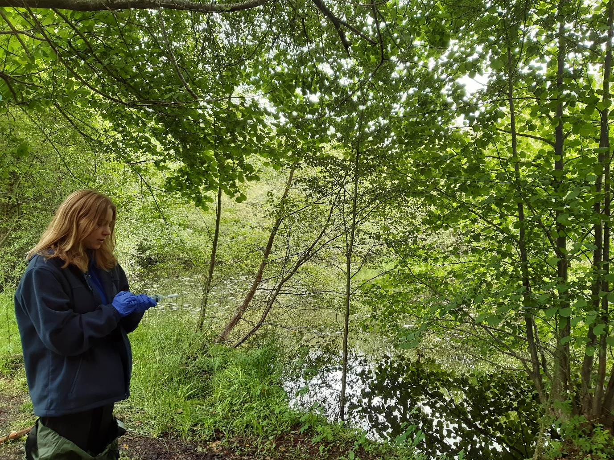

Work-based learning placement student Airren Martin carrying out on-site eDNA filtering at the beaver pond, Hatchmere Beaver project, Delamere Forest, Cheshire.

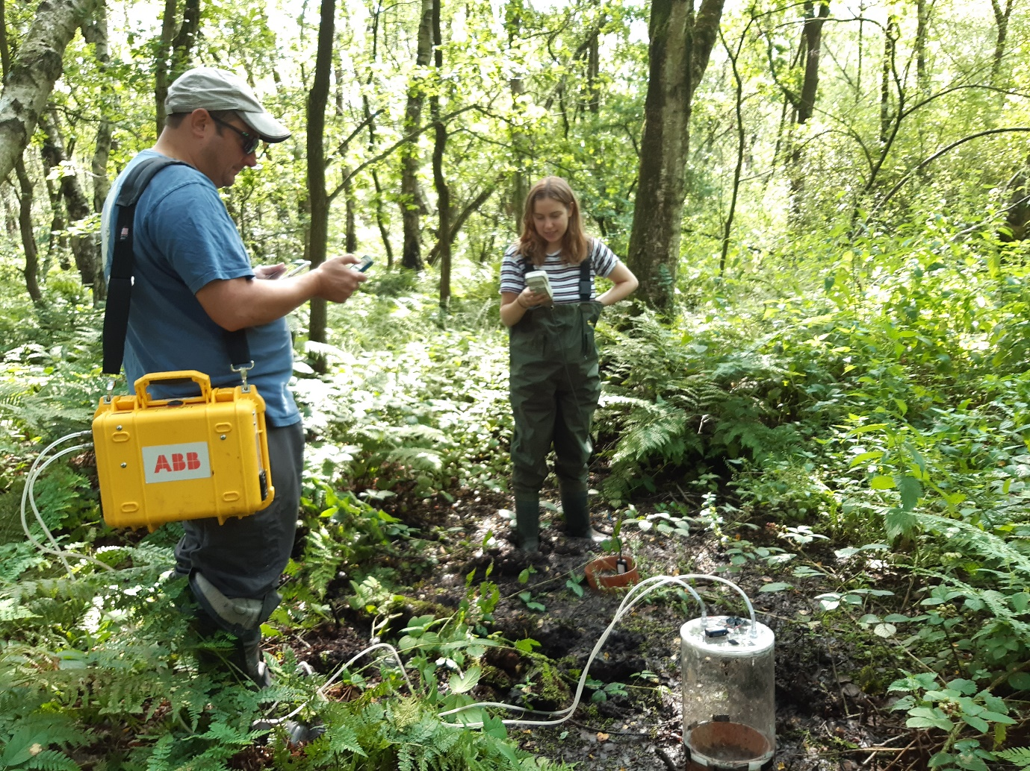

Work-based learning placement student Airren Martin assisting LJMU PhD candidate Mike Longden with data collection of greenhouse gas emissions, Hatchmere Beaver project, Delamere Forest, Cheshire.

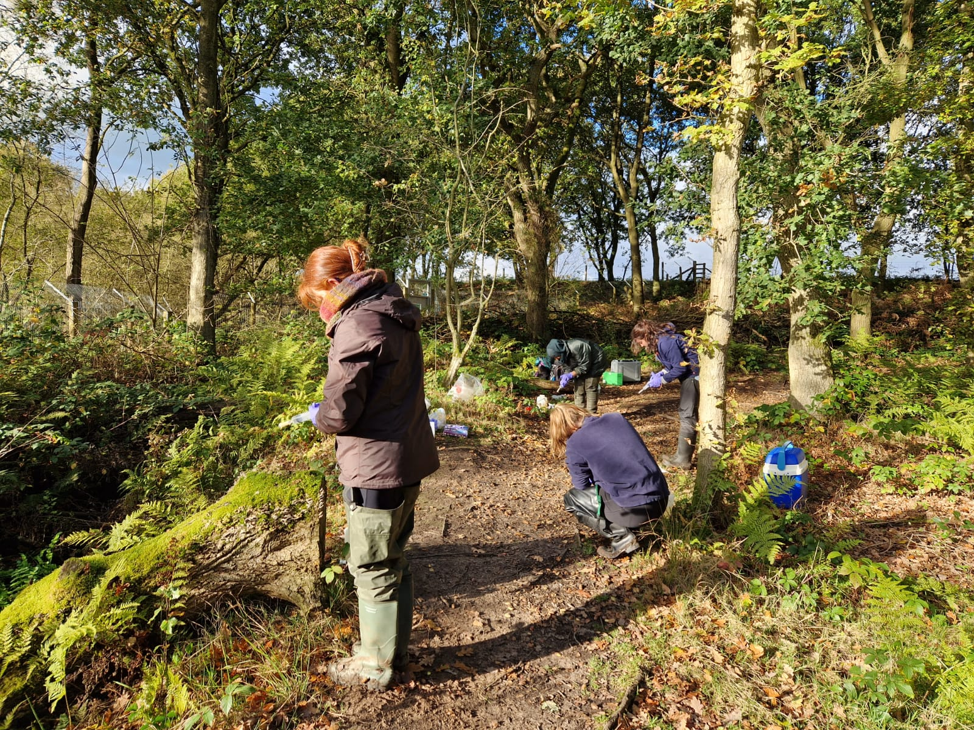

Volunteer students assisting with on-site eDNA filtering at the beaver pond, Hatchmere Beaver project, Delamere Forest, Cheshire.

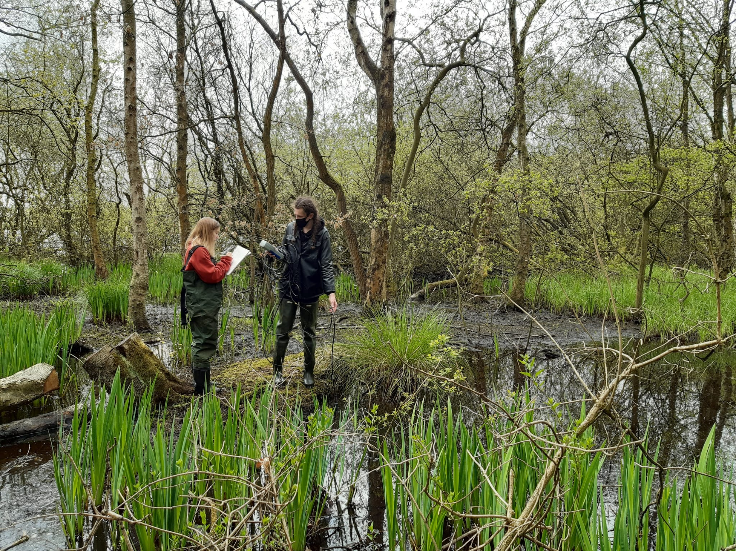

Volunteer students assisting with the measurement of physico-chemical water parameters, Hatchmere Beaver project, Delamere Forest, Cheshire.

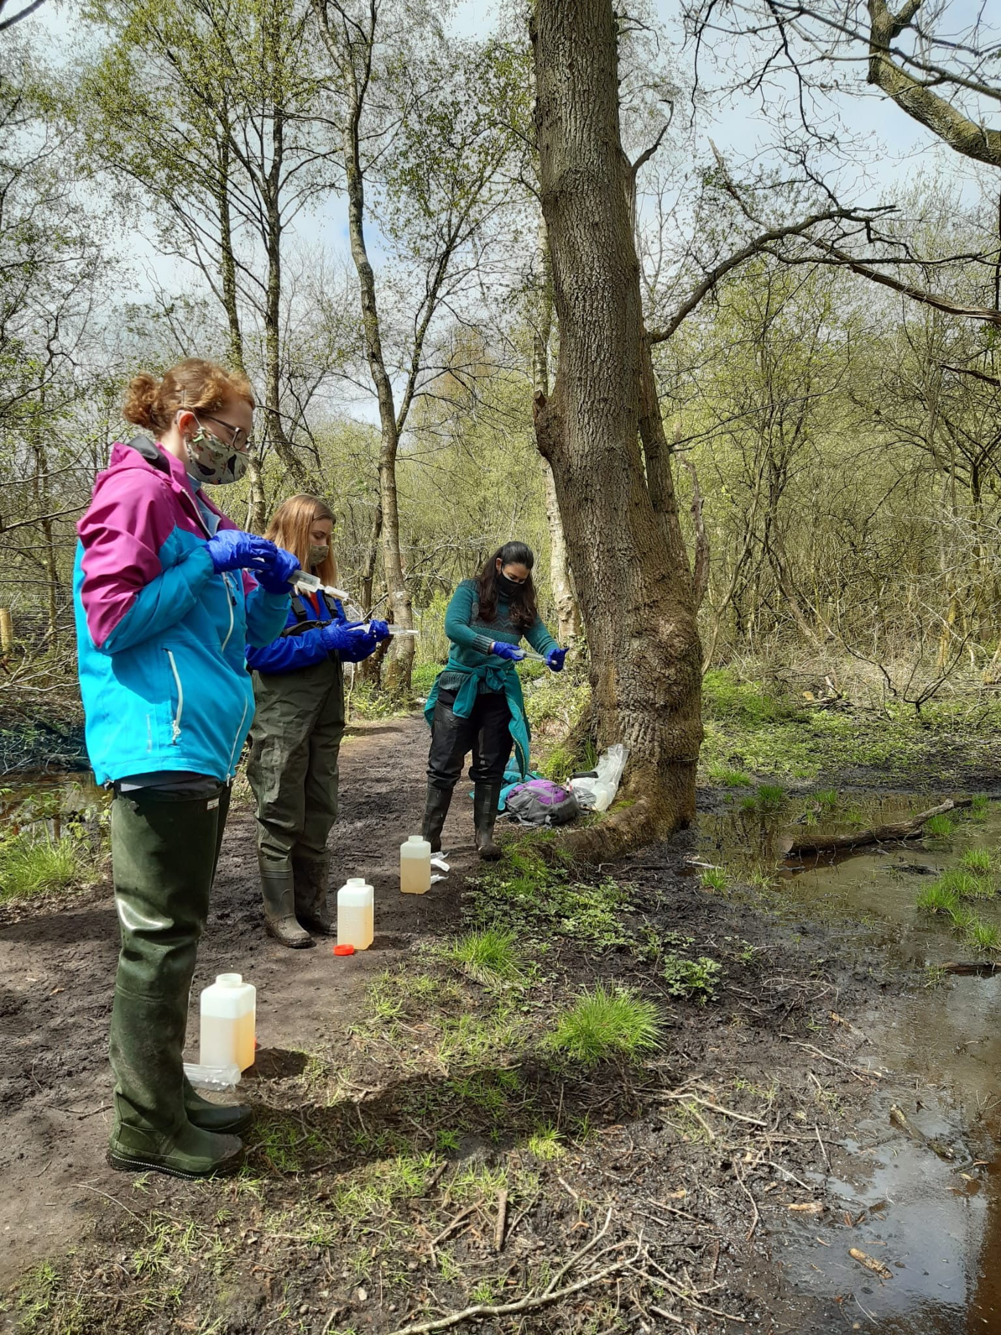

Staff and volunteers students assisting with on-site eDNA filtering, Hatchmere Beaver project, Delamere Forest, Cheshire.

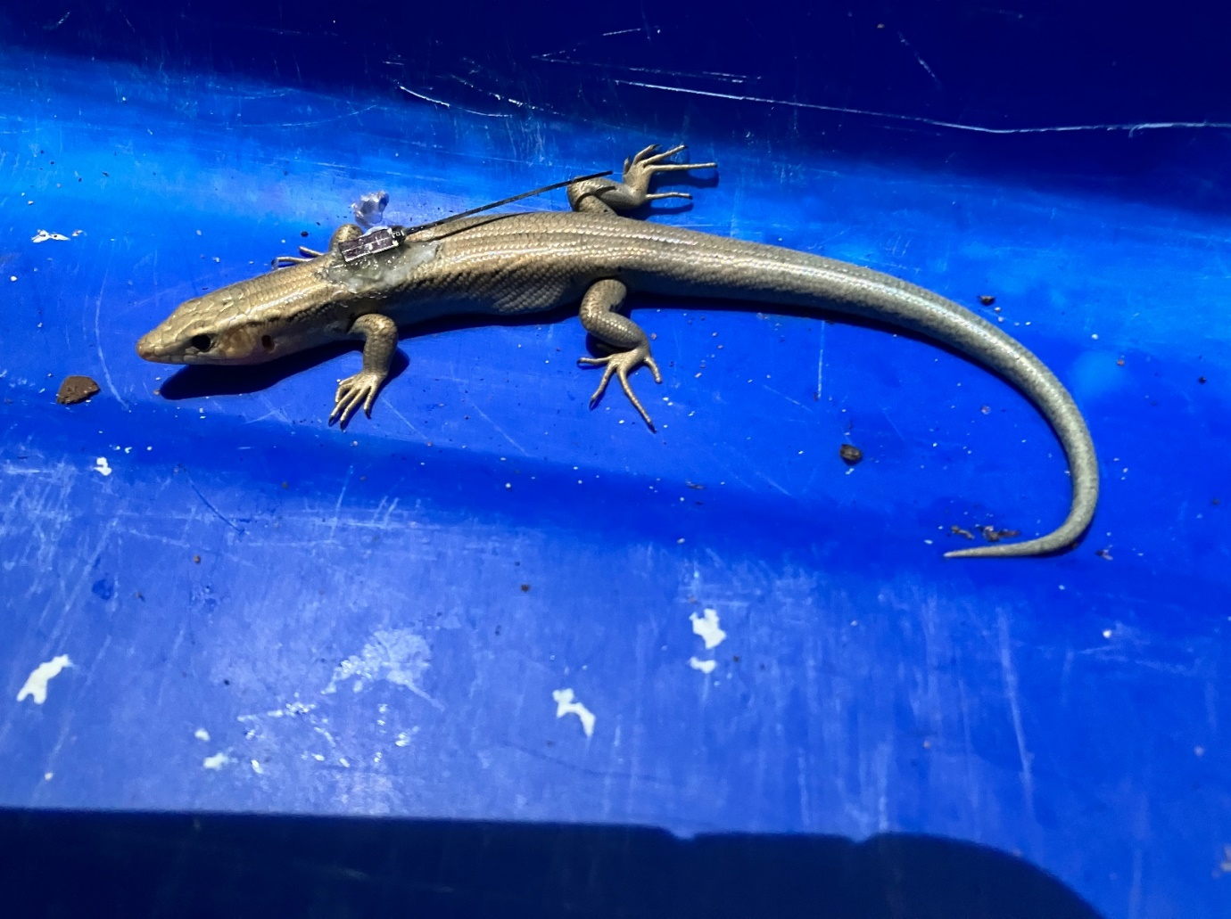

Captive bred Bermuda Skinks being release into Trunk Island (Bermuda) with transmitters to monitor their activity patterns.

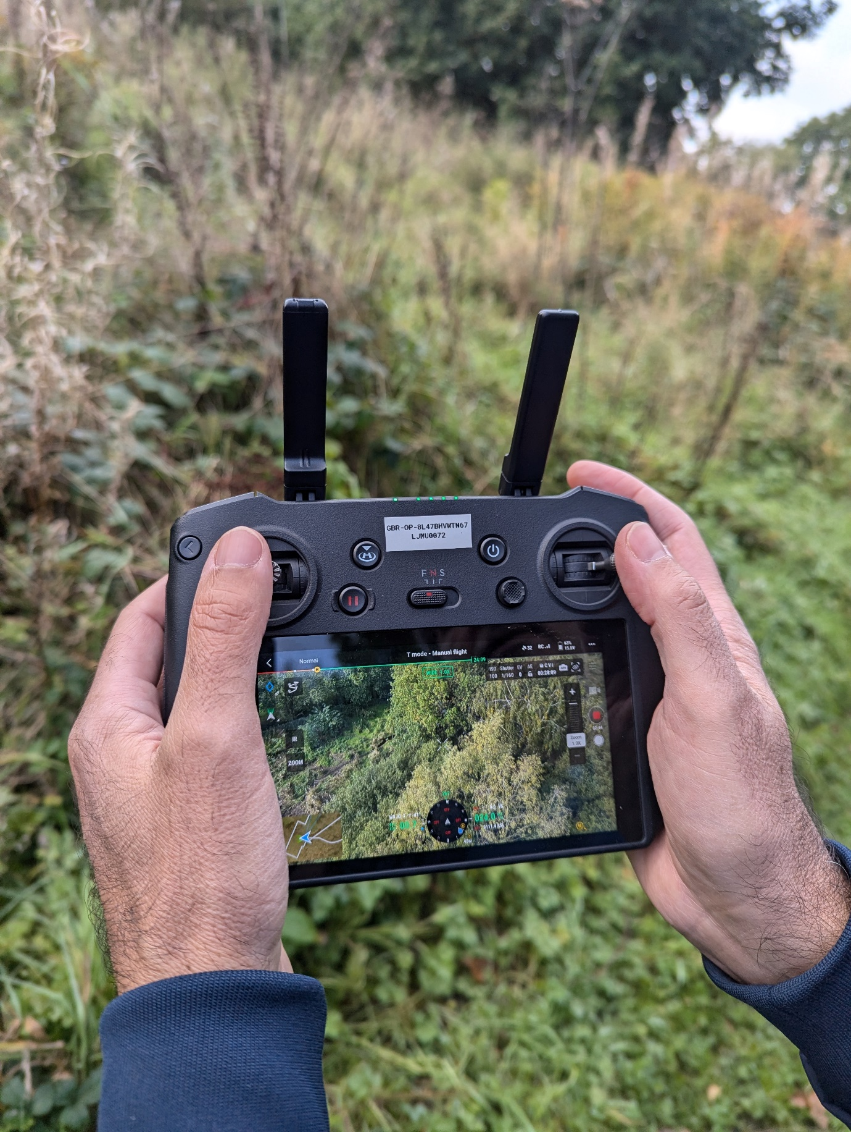

Drone technology being used to monitor beaver activity in Hatchmere, Delamere Forest, Cheshire