# **Research-Informed Teaching case study: HR Employability – The development of employability skills, networking opportunities and job opportunities for Human Resource undergraduates and graduates.**

Dr Patricia Joliffe

Office for Students (Office for Students, 2021) research shows significant performance differences between universities in terms of students securing professional employment or further study shortly after graduation. At 25 universities and other education providers, less than half of students who begin a degree can expect to finish that degree and find professional employment or further study within 15 months of graduation, the time that the data is captured. Office for Students (Office for Students, 2021) states, ‘It is important that prospective students have access to good independent information about courses they may be interested in’. Whilst 72.7% of our HR undergraduate students (2019/20) achieved high-skill employment captured via the Graduate Outcomes Survey (GOS), is positive, employability must maintain a priority.

Furthermore, the advent of Generative AI in 2023 has not just altered recruitment and selection processes (Thakur, Hinge, & Adhegaonkar, 2023) but also directly impacted the student population in this case study. They must remain abreast and adjust to these changes, as they are both initiators and participants in the process.

**Specific Project Work**

As a Human Resources (HR) professional with a PhD who explores professional development, I value supporting students in becoming leading HR professionals. In 2015, I developed the Professional Student Network Group (PSNG), a unique, student- and academic-led partnership approach to professional development that uses social media. Unlike any other in the field, this innovative approach has proven to be highly effective. Every September, I recruit 13-17 volunteer Master’s and BA students from all HR programs. Eight years of digital collaboration on this project has led to an HR website (ljmuhr.wordpress.com) that helps to connect, transform, and create unexpected yet powerful learning opportunities. The website is supported by social media platform activities: HR X with 2424 followers; HR Instagram with 462 followers, HR Facebook with 400 followers and HR LinkedIn with 490 members. Social networks are essential to individuals, e.g., Instagram targets Gen X and Y, whilst LinkedIn links all professional alumni. PSNG has supported c.5 CIPD events per annum and helped to organise two conferences, ‘Changing HR’ 2017 and ACERT (ACERT, 2023).

My research, which resulted in a book chapter in *The Future of HRD*, Volume 1 (Harrison, Nichol, & Gold, 2020) on Artificial Intelligence and the profession, is innovative and groundbreaking. The research highlighted practitioners' limited knowledge of AI.

**Impact on curriculum**

I have used learning in practice to help HR students develop their employability skills. My research identified the increased prevalence of AI/Gen AI, such as the use of chatbots in the recruitment process. Thus, I redesigned my 2023 employability module, introducing practical activities to enable students to successfully achieve chatbot/person interviews. I also developed the module further via my international teaching experience in France (January 2024) and Prague (March 2024).

I go above and beyond to support my students in finding full-time and part-time work. The email I received from Dave, an HR student in March 2021, I think, sums up the extra mile I go ‘*We did it, we did it, we got the job (Dave, HR Student 2021)*’. Dave’s background as a BAME, first-generation university student resulted in us working closely to identify and record his significant, exciting, and relevant work experience. Whilst Nicole (HR student 2024) shared how being part of the PSNG had made a difference in securing the first placement she applied for.

PSNG creates a broader impact on student experience and employability, including advertising HR positions, guest speakers, or mock interviews. For example, in November 2023, I invited HR practitioners on our social media platforms to help with mock interviews, and I received 22 responses within two days. I organised online mock interviews for five students at all HR levels. One student shared how she secured a job with the NHS because of the practice. She felt ‘confident’ and ‘prepared’ for the interview. The mock interview has now been incorporated into the Assessment Centre experience that most Business School students attend. Students also broaden their experience and ‘give back’ to others, as demonstrated in the publication developed by two of the past PSNG students, Ines Coutinho and Elle Maguire, who worked with myself and Helen Collins on Project Dream (Sarcol, Coutinho, Maguire, Collins, & Jolliffe, 2024)

Another example is when, in 2022, Amey (employer of 14,000 staff), after building a fabulous relationship with Placement Student Unit (PSU), offered two of our HR students’ yearlong placements. However, one declined. They asked us to recommend further students. Our HR team and the PSNG group spread the word about the opportunity. PSU and I offered them targeted support. Also, the student who had been successful shared their application. We recommended four students: Level 5 HRM, Level 6 HRM, and Two F/T Masters. Amey unexpectedly offered one student the placement and the other three Graduate positions with excellent starting salaries (£21k to £25k). Several students had no HR experience and are delighted to have secured this excellent local opportunity. Since then, Amey has offered other LJMU students part-time work alongside their studies.

**Broader Change**

The overall student experience at PSNG has been extremely positive. Students gain from internal networking across the HR programmes and external networking with HR practitioners. Furthermore, we can see the benefit to student on their employability outcomes.

**Table 1** shows the employment secured for level 5 and 6 undergraduate PSNG members from 2015-2020 and the overall graduate outcomes data.

|  |  |  |
| --- | --- | --- |
| **Year** | **Level 5 Internships secured** | **Level 6 Graduate roles secured** |
| 2015-2016 | 100% | 75% |
| 2016-2017 | 67% | 100% |
| 2017-2018 | 100% | No data as no level 6 member |
| 2018-2019 | 100% | 100% |
| 2019-2020 | 100% | 100% |

In 2018-19 the HSE LJMU HRM Average graduate outcome was 66.7 and HSE Leavers Average 69.2. Whilst in 2019-2020 the HSE LJMU HRM Average was 72.7 and HSE Leavers Average 70.5. Furthermore, the students develop close bonds with the academic staff. These points are illustrated in the student feedback:

‘I got more out of it than I thought I would (laughs), which is great. I think I met more people than I thought I would –‘ Hiba

‘Yeah, and my title on LinkedIn is obviously Chartered Institute of Personnel and Development (CIPD) Co-ordinator, so at the interview, they asked me what that role consisted of.’ Bronagh

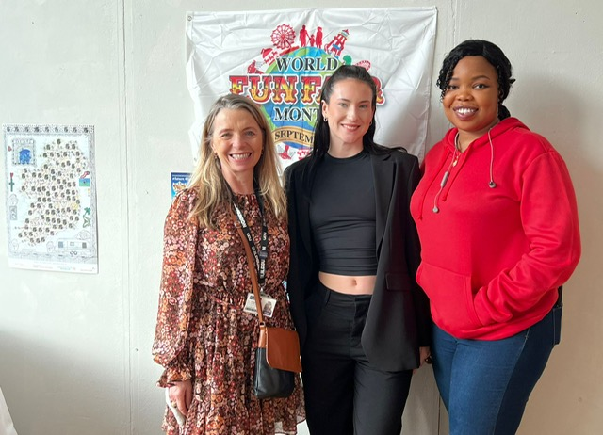

ACERT Conference 2023 Dr Tricia Jolliffe with Nicole Richardson and Obianuju Obiagwu (PSNG members)

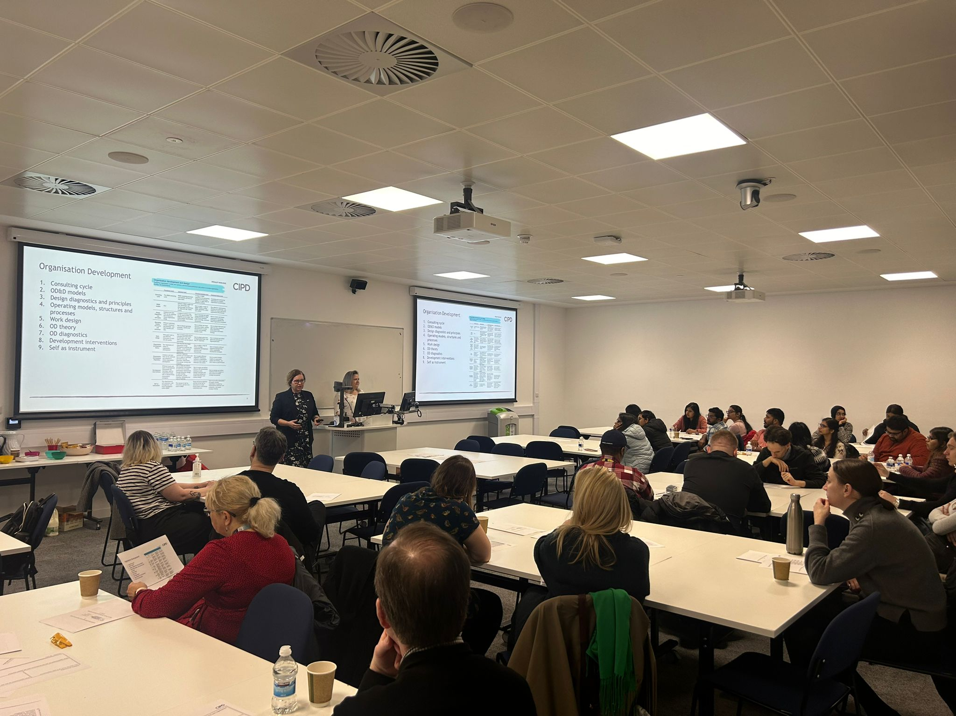

CIPD Event 2024 – HR Practitioners (PSNG supported)

In summary, the HR Students and Academic Department has:

* Increased constructive learning and networking across the student group and with external HR professionals.
* Increased use of social media has provided greater opportunities to share knowledge. The project has led to the development of the LJMU Website, HR Facebook, LinkedIn HR Group, and X.
* Secured better student graduate outcomes for students who have volunteered in the PSNG scheme.

**References**

ACERT. (2023). Storytelling, Education and Wellbeing. Retrieved from <https://acert.org.uk/the-conference-takes-shape-duplicate-1/>

Harrison, P., Nichol, L., & Gold, J. (2020). Redefining HRD Roles and Practice in the Machine Learning Revolution. In M. Loon, J. Stewart, & S. Nachmias (Eds.), *The Future of HRD, Innovation and Technology* (Vol. 1, pp. 143-166). Switzerland: palgrave macmillan.

Office for Students. (2021). New measures shows substantial differences in likely job and study outcomes for students. Retrieved from <https://www.officeforstudents.org.uk/news-blog-and-events/press-and-media/new-measure-shows-substantial-differences-in-likely-job-and-study-outcomes-for-students/>

Sarcol, E., Coutinho, I., Maguire, E., Collins, H., & Jolliffe, P. (2024). Exploring Women's Education and Employment Opportunities in India, Syria, and the Philippines. *The Qualitative Report, 29*(1). doi:10.46743/2160-3715/2024.5728

Thakur, A., Hinge, P., & Adhegaonkar, V. (2023). *Use of Artificial Intelligence (AI) in Recruitment and Selection.* Paper presented at the ICAMIDA.