# **Research-Informed Teaching case study:** **Developing teamwork and communication competence - two of the most important management competencies employers worldwide** **seek**

Liverpool Business School: Dr Phil Kelly, Dr Chin Ong and Dr Moustafa Haj Youssef

**General Context**

Teamwork (working with others to achieve a goal) and communication competence, often in the context of intercultural workplaces, are two of the most important competences demanded by employers worldwide (*see* for example “the KSAs Companies Expect from Business School Graduates: Corporate Recruiters Survey 2018”[1] – Graduate Management Admission Council). Within this context, educators must promote diversity, design a fair assessment, develop the student’s requisite knowledge and skills, and make judgements about a group’s work. However, these are complex tasks. Longitudinal research between 2008 and 2019 in the Liverpool Business School (LBS), has been applied to develop teaching technology and pedagogy to engage students, develop and assess group work presentations – in the context of the international and diverse classroom.

**Specific project work**

Research undertaken by the LBS postgraduate team (led by Dr Phil Kelly – Reader in Management, Dr Chin Ong, and Dr Moustafa Haj Youssef with Dr Yvonne Moogan) into group work, the challenges of the international classroom, and the development of communication competence, over the past 15 years has led to significant new knowledge about international pedagogy and competence development as well as the creation of key tools and technologies for group formation, development, and assessment. For example, research focussed on *Culture Shock and Higher Education Performance: Implications for Teaching* was published in Higher Education Quarterly using data collected over a ten-year period and analysis of over 15,000 postgraduate assessments. Here, the research found a significant performance difference between home country students (HCS) and international mobile students (IMS). Results found that HCS perform significantly better than IMS, although the latter perform better in examinations than in coursework. Such insights were used to redesign their international pedagogy.

The LBS postgraduate team used their findings to argue higher education institutions needed to do more to support their internationally mobile students. Associated technology developed by this team (Multicultural Group-Work - The Group Allocation Process) was disseminated at several T&L conferences (such as the Higher Education Academy Annual Conference, 2008, The London Scholarship of Teaching and Learning conference 2010 and the LJMU Learning and Teaching Conferences in 2012 and 2019). The technology presented an algorithm to automatically separate a cohort into diverse multicultural groups using a simple spreadsheet. This and other developed technologies led to the creation of a new touchscreen system to manage group formation, communication, and assessment - (see figures 1-4).

Student feedback evidence tells us the approach develops, motivates and engages student groups; it also facilitates the development of transferrable skills (Liverpool Business School Post Graduate student Eliza Sharp (2020) stated, “I extremely enjoyed the course. I really feel that I have really broadened my knowledge and now can’t wait to apply it within a job in the real world”; Module specific feedback includes comments such as “Working in a group is a completely new experience to me. It was challenging but I have learnt a lot from it.”; “This module helped me to engage with group work, … and it developed my skills enormously.” [International student]).

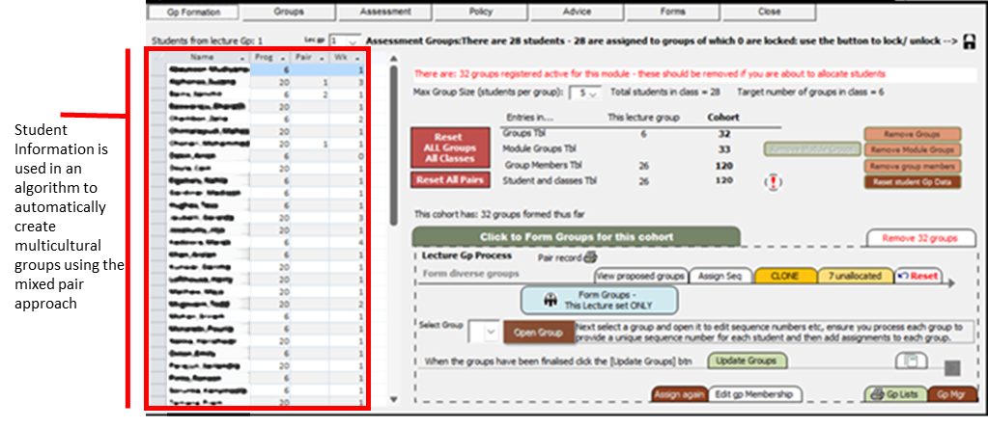

Figure 1 Group Formation Tool

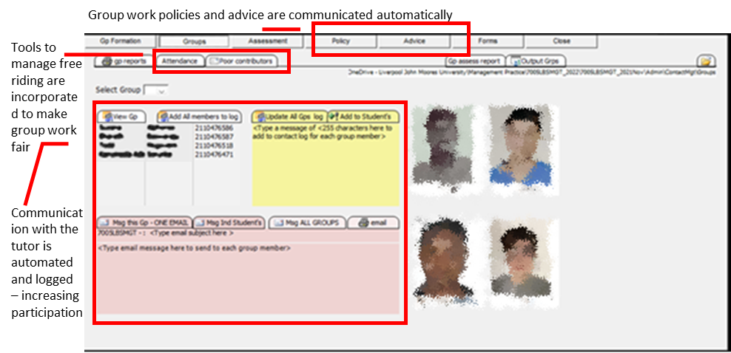

*Figure 2 Group Communication enabled technology (photos blurred for confidentiality)*

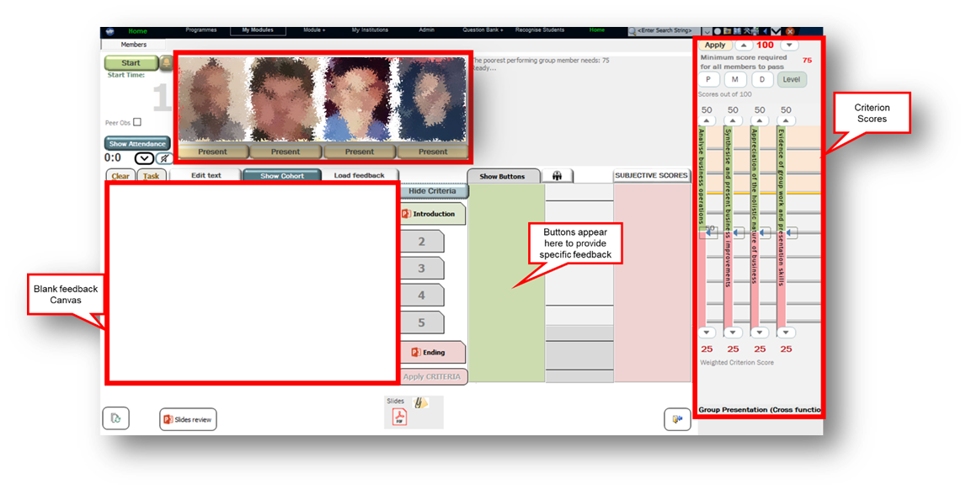

Figure 3 Main group assessment application page

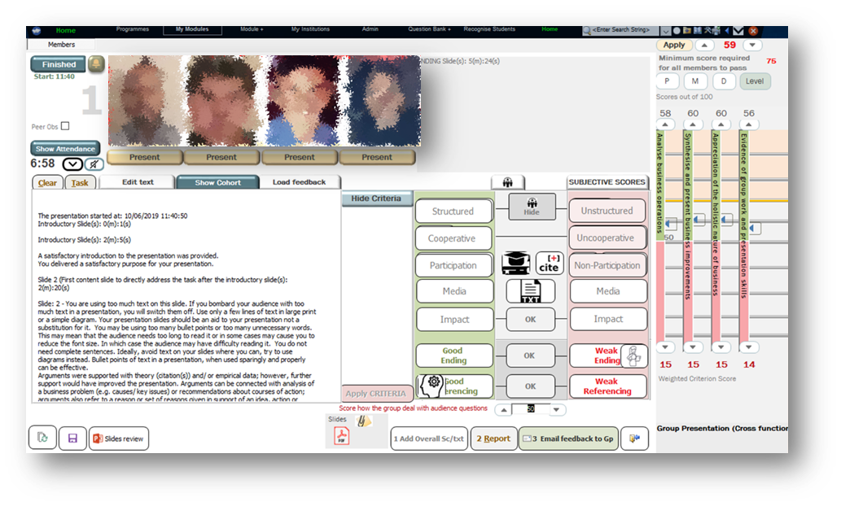

Figure 4 Populated with group feedback

**Impact on Curriculum**

New knowledge from this research has been encoded into programme and module design, pedagogy, teaching and learning and assessment resources. An article written for the *Team Performance Management Journal* was used by the University of Worcester to create a guide for teachers on “Being inclusive in small group teaching”. Scholars drew on our research at the University of South Australia to publish work concerning the “Allocation of Tertiary Students for Group Work: Methods and Consequences”.

We have created two new Liverpool Business School core modules (delivered on six of the School’s Master’s programmes and adopted by a collaborative partner in Vietnam), one of which, *management practice,* was created specifically to develop the management competencies highlighted by the Graduate Management Admission Council and thus enhance students’ employability. To facilitate this, new teaching technologies were created that allow diverse student groups to be created (by algorithm) and communication with them managed. Group presentations are assessed using touch screen technology (see figure 3) - enriching timely feedback. A blank (feedback) canvas is automatically populated (see figure 4), through the dynamic button-set used to provide specific feedback and sliding scales used to allocate scores as the presentation proceeds. Upon completion, the comprehensive feedback report is generated immediately and automatically emailed to each of the group members (students). The system is used to assess both formative and summative presentations whilst developing student group and presentation competence (directly enhancing employability – students became more able to work in groups and deliver group presentations).

Following implementation of our international pedagogy, new modules, and use of the software, student feedback evaluation reports have been very positive, stating: “Prompt feedback comments on assessments and presentations were very encouraging!!!”. The overall student’s satisfaction score was 4.51 (school average 3.93); responding to the statement “I have received helpful comments on my work:” the management module scored 4.55 compared with a school average of 3.89.

Following further developments, the next year, students recorded a satisfaction score of 4.68; comments included, “The presentations have been eye opening in the ways we present”; “The lecturers' way of delivering the module is on the top-notch, … well explained points and quality group work. - It is the best module so far.” Other students commented, “It was an absolutely fantastic course to make us understand group working”. “The best part of the module is that it focuses on presentations which is a great opportunity for students who lack presentation skills”.

For the three years between 2019 and 2022 approximately 400 postgraduate students enrolled on Master’s programmes such as MSc Management, MSc Management and Digital Business and MSc International Business and Management were directly impacted by this work.

**Broader Change**

Through diffusion via conferences, journal articles and textbooks, the research has been used across HE to influence practice in relation to teamwork and intercultural group work. It has, for example, been integrated into one of the leading seminal undergraduate texts in business and management, *Management Theory & Practice* (the 9th Edition was updated to reflect research findings on group work and management competence development in particular). This book has a global influence with various editions available in 237 libraries worldwide (see World Cat). It can be obtained in at least 125 university libraries spanning 37 Countries. 47 UK universities and many of their degree programmes hold various editions of the book, which is also available throughout Europe, for example, it is available in 10 of Germany’s universities. Aside from University adoption, the book (previously an Amazon Management Science number 1 best seller) has also been adopted by many organizations – such as the NHS. Lecturers worldwide have reached out to the team, for example, Arsalan Waheed, NED University - Pakistan, emailed (August 2023) “It was a great pleasure to come across your YouTube channel by chance and through it found about your authored textbook: "Management - Theory and Practice". I was fortunate to find a copy of the book in our library and immediately decided to adopt it for my postgrad diploma students”.

The research published in *Higher Education Quarterly*[2] has now been cited in 139 other publications. inspired studies around the world and featured in the “Handbook of Research on Transnational Higher Education”. This work has been referred to in country studies such as the Internationalisation of Irish Higher Education and the Harrison report for the Office for Learning and Teaching (Australian Government). The study was reported in the OECD HE publication, “Approaches to Internationalisation & Their Implications for Strategic Management and Institutional Practice - A Guide for Higher Education Institutions”; additionally, Cottrell (2019) cited the work in ‘50 Ways to Succeed as an International Student’.

Work has been shared in several T&L journals and conferences, and the team have also given guest lectures at various UK universities. As noted, the work has been used to enable aspects of teaching and learning strategy. Dr Kelly’s activities were recognised with an Excellence Award (2022) from the Liverpool John Moores University Vice Chancellor for high quality contributions using technology to enhance the activities of the post graduate team. The Liverpool Business School Post Graduate team now intends to convert and share the prototype as a working solution. This will be presented and made available at a forthcoming AdvanceHE Teaching and Learning Conference.

1. Knowledge, Skills, and Abilities
2. Kelly P, Moogan Y. 2012. Culture Shock and Higher Education Performance: Implications for Teaching Higher Education Quarterly, 66 :24-46