**Research-Informed Teaching: *Developing critical knowledge of marine asset management through innovative risk-based integrity management, Life-cycle assessment, and decision-making techniques in industrial applications.***

**General Context**

*The offshore oil and gas industry on the UK Continental Shelf (UKCS) is a mature production area. Much of the offshore infrastructure is at, or has exceeded, its intended design life. From 2004 to now, there have been numerous programmes run by the Health and Safety Executive aimed at such events as, reducing hydrocarbon releases, focusing on the integrity of process plant, to the life extension of physical offshore assets and now decommissioning with transition to renewable and alternate energy sources. For more than 10 years, LJMU has worked in collaboration with the UK offshore industry to provide valuable new knowledge, through research, regarding the integrity and safety of marine assets. The School of Engineering runs a module entitled “Marine Maintenance and Asset Management” led by Dr. Sean Loughney and supported by Dr. Eddie Blanco Davis. Both Dr. Loughney and Dr. Blanco-Davis utilised their research and industrial knowledge to develop the module in 2019. Since then, the module has evolved based on the current research activities, in tandem with the changing landscape of the UK marine industry.*

**Specific Project Work**

*Dr. Loughney and Dr. Blanco-Davis lead the module within the School of Engineering. The basis for the research-led module was Dr. Loughney’s PhD work (completed in 2018) related to asset integrity management of unattended offshore installations. This work was conducted in tandem with an offshore consultancy company (RMRI Plc.) and offshore regulators (HSE) to produce novel dynamic risk-based integrity management methods. An example of the input from a specific PhD study was Dr. Cameron Kelly’s PhD work, supervised by Dr. Blanco-Davis, “An Investigation into the uses of Life Cycle Analysis as an Alternative Method of Site Selecting tidal Power Schemes”, to highlight the capabilities of LCA as a decision support tool in industrial applications. Lastly, Dr. Blanco-Davis has also utilised his own research projects and experience regarding Life-Cycle Assessment of Marine systems and structures to supplement the taught module. Since the development of the module the research picture has progressed within the UK Marine industry and a number of students, staff, and projects, within the School of Engineering and beyond, continue to supplement the research led module. Joe Ford (VC Studentship), Dr. Cameron Kelly (Research Assistant – Built Environment), Dr. Ariel Edesess (Research Assistant – Built Environment) Jack Diver’s (VC Bicentenary Scholarship), have all been involved with research studies that assess the integrity and safety of offshore energy structures. This includes structural fatigue analysis, condition monitoring, life extension and safety of decommissioning, the environmental effect of offshore operations, and the planning and implementation of renewable and alternative energy projects. Similarly, the module team have also been involved in projects that have made contributions to the research led content, these include ARCWIND (EU Project), RESET (EU Project), RETROFIT55 (UK Research & Innovation) and multiple Quality-Related Policy Support Impact (QR PSF) Funding (Research England). As well as engagement with industrial operators such as, DecomMission, Oil & Gas UK (OGUK) and Scottish Environment Protection Agency (SEPA). The work produced represents a great contribution to the UK offshore energy industry both in terms of maintaining integrity and safety of large physical assets right down to the safety critical equipment. Similarly, in conducting this research, a range of specialist knowledge and skills has been demonstrated, which is continuously developed for the postgraduate module.*

**Impact on curriculum**

*The initial change was to the Marine and Offshore Engineering MSc program where the “Marine Maintenance and Asset Management” module was introduced as a core module in 2019. However, there are updates and additions to the module’s research content on a regular basis as developments in the field are continuous (e.g. techniques, standards policies and regulations are constantly reviewed. This constant adaptation of the research and module content in the ever-changing UK marine industry keeps the knowledge current and cutting edge for the students. What is also vital is the exploration of new themes and techniques that could potentially be utilised in the industrial led research. What the module team is very conscious of is not to defer from the learning outcomes stated in the Module Proforma, but what does become affected is the syllabus. This is inevitable as this operates in tandem with the current research and operational practices. This is also vital as the module is offered as an option on another MSc programme; “Maritime Operations Management” and a New MSc Programme “Renewable Energy”. Thus, constantly reviewing and maintain the module to remain relevant across multiple programmes becomes a challenge, but one that has been welcomed and tackled since the module’s inception. With the introduction of the new programme, module content has been diversified to include aspects of integrity and asset management for the point of view of offshore renewable energy structures, the transition of offshore hydrocarbon production to renewables and the inclusion of alternative fuel development and infrastructure. This has been supplemented by the research work of two PhD students supervised by both Dr. Loughney and Dr. Blanco Davis related to “Sustainability in the decommissioning process of UK offshore installations and the management of hazardous waste” (Joe Ford) and “Investigation into the viability of hydrogen fuels in commercial shipping vessels to improve shipping industry sustainability” (Jack Divers).*

*What has been an excellent outcome of the module is the reception of the students to the content. The module consists of students that have arrived direct from undergraduate and from industry. In many instances the students from industry are chief engineers or ship masters, thus they have very precise expert knowledge. These industrial experienced students welcome the research aspect to the field. One such example is the application of dynamic risk based in integrity technique to monitor a one-point failure in an offshore power generation system. The tutorial identifies an unknown failure that occurs and highlights how this impacts the integrity of the system in terms of the increase in magnitude of the risk levels. Thus, leading to inspection and maintenance regime changes. This offers a unique insight into the research and industrial techniques used in practice in offshore energy structures. The opinions of the students are reflected in the very positive module evaluations each year.*

**Broader Change**

*The research-informed MSc module has resulted in students, both direct from undergraduate and those from industry, widening and improving their knowledge in the marine and offshore field. This has led to students identifying a much broader idea of their career prospects and opportunities. Some examples of student progression from the course, which contain the Research-Informed Teaching module and are relevant to the module content, are a lecturer in Marine Engineering at Fleetwood Nautical College; Marine Engineer at Brookes Bell; Marine Surveyor at Bennett Marine Associates Ltd; Technical Research Assistant Liverpool John Moores University; and Chief Engineer Synergy Marine Group. One thing that the module facilitates is industrial report writing. There is no exam in the module, it is instead assessed through two reports currently related to Lifecycle Assessment & Condition Monitoring, and Asset Life Extension and Decomissioning. The students are required to use the taught research methods and techniques to produce industrial style reports. This is further supplemented by both Dr. Loughney, and Dr. Blanco-Davis having utilised their research to produce industrial reports for regulators and key stakeholders (HSE and IMarEST). This further provides an enhanced skill to widen career opportunities. Furthermore, the research developed by Dr. Loughney, and Dr. Blanco-Davis has been used to develop impact cases in UoA 12: Engineering for REF 2021. Students have conducted relevant MSc projects following on from the taught module and have produced great results in terms of applying the taught techniques to issues experienced in their time industry. 2 students stand out; one achieved close to 90% for their MSc thesis and used the project to develop a PhD research project, now used to supplement the taught module (Joe Ford – Supervised by Dr. Loughney). The other student utilised the techniques and methods underlined in the module, and under the supervision of Dr. Blanco-Davis won the highly competitive Maritime master’s award from Maritime UK (2021), ultimately obtaining a shipping LCA-related PhD scholarship in the University of Plymouth.*

*The opinions of the students are reflected in the very positive module evaluations each year. The module has maintained an average score of 4.4/5 in 19/20, 20/21, 22/23 and 23/24 across all MSc programmes with 22/23 producing a pass rate of 100%, with an average grade of 66%. Furthermore, the 23/24 cohort has also produced a 100% pass rate with an average grade of 79%.*

***Student Comments:***

* *“Excellent course structure and teaching”*
* *“I enjoy the lack of exam for this module. Allows the tutorials to become a good space for discussion and sharing of ideas.”*
* *“Highly relevant with future career progression.”*
* *“very interesting and found effective with my experience.”*
* *“Challenging me to think more deeply about the subject area.”*
* *“Dr Sean and Eddie offered us a plethora of possibilities within this module, opening our eyes to things, as someone from the maritime industry was ignorant about. Many things were made easier for us to understand, even complicated notions and concepts of management within the offshore industry concerning asset management and maintenance. I have nothing but gratitude towards them.”*
* *”This module runs like a well-oiled machine. I cannot think of any way to improve this module”.*
* *“The most interesting aspects are the managerial role to act as the superintendent engineer. Recently, we were thought about the Life cycle which is very interesting as well.”*

**Teaching Example**

*Below are some Tutorial examples from the course content that are based on real world industry and research scenarios, which are used to inform the content and delivery. They also aid in supplementing the concepts that are taught. The Tutorial Example is a student favourite as they demonstrate a minor change in consequences related to integrity failure of large offshore power generation machinery. This concept is used to inform inspection and maintenance practices and scheduling for large engineering systems.*



Figure 1: Tutorial example of a Bayesian Network to demonstrate change in likelihood of consequences based on a single point failure for a large engineering system (Loughney & Wang, 2018a), (Loughney et al., 2018b).

*Tutorial Example: “A risk assessment study indicated that due to maintenance inspections, the rotor retaining rings in the gas turbine driven power generator, were exposed to the sea air and water. This has been determined to affect the integrity of the retaining rings, leading to unpredictable stress fracture and failure”. This is a real case study of a specific offshore installation in the North Sea.*

*Figure 1 shows the probability of 100% failure and 100% no failure of rotor retaining rings and the occurrence probability of the potential consequences (E1 to E7). Figure 2 shows the change in the likelihood of one specific consequence and asks if the combined probability and consequence are at an acceptable risk level. We would then have some discussion around the student choices on the acceptable risk and why they would think this, as well as how it affect the inspection and maintenance regime of the offshore platform in question. Figure 3 shows the change in the risk matrix based on what appears to be a negligible change in likelihood. What it demonstrates is that revisions to the inspection and maintenance programme are required as the risk is no longer at an acceptable level thus the integrity of equipment and safety of personal are at increased risk.*

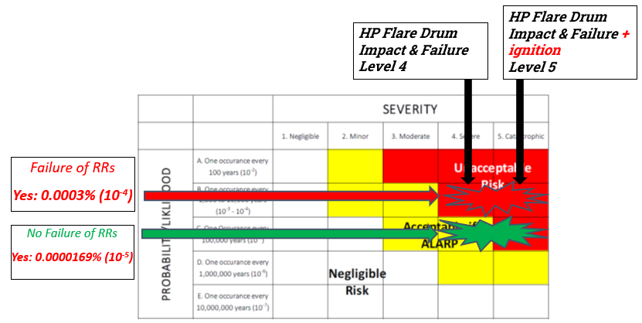

Figure 3: Demonstration of how the risk level of an event can change through a single point failure and changes in magnitude of occurrence probability (Loughney & Wang, 2018a), (Loughney et al., 2018b).

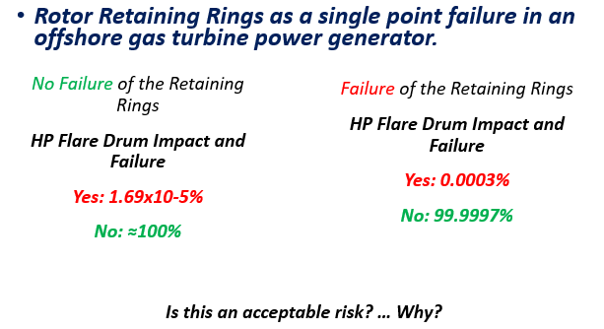

Figure 2: relationship of one single point failure to a single consequence and it's change in likelihood of occurrence. (Loughney & Wang, 2018a), (Loughney et al., 2018b).

**References**

Alghanmi A, Yang Z, Blanco-Davis E. 2020. Risk analysis of petroleum transportation using fuzzy rule-based Bayesian reasoning International Journal of Shipping and Transport Logistics, 12: 39-64.

Cutler J, Bashir M, Yang Y, Wang J, Loughney S. 2022. Preliminary development of a novel catamaran floating offshore wind turbine platform and assessment of dynamic behaviours for intermediate water depth application Ocean Engineering, 258.

Fan S, Blanco-Davis E, Yang Z, Zhang J, Yan X. 2020. Incorporation of human factors into maritime accident analysis using a data-driven Bayesian network Reliability Engineering and System Safety, 203.

Jenkins M, Loughney S, Matellini DB, Wang J. 2024. Advancing the Sustainability of Risk Assessments within the Renewable Energy Sector—Review of Published Risk Assessments Sustainability, 16.

Loughney S, Wang J. 2018. Bayesian network modelling of an offshore electrical generation system for applications within an asset integrity case for normally unattended offshore installations Proceedings of the Institution of Mechanical Engineers, Part M: Journal of Engineering for the Maritime Environment, 232: 402-420.

Loughney S, Wang J, Bashir M, Armin M, Yang Y. 2021. Development and application of a multiple-attribute decision-analysis methodology for site selection of floating offshore wind farms on the UK Continental Shelf Sustainable Energy Technologies and Assessments, 47: 101440-101440.

Loughney S, Wang J, Matellini DB, Nguyen TT. 2021. Utilizing the Evidential Reasoning approach to determine a suitable wireless sensor network orientation for asset integrity monitoring of an offshore gas turbine driven generator Expert Systems with Applications.

Loughney S, Wang J, Matellini DB, Pemberton K. 2024. Investigation and analysis of ship to platform collision incidents on the UK continental shelf: highlighting trends between the enforcement of offshore regulations and the occurrence of vessel to platform collision incidents Journal of Marine Engineering and Technology, 1-16.

Yang Y, Bashir M, Wang J, Michailides C, Loughney S, Armin M, Hernandez S, Urbano J, Li C. 2020. Wind-Wave Coupling Effects on the Fatigue Damage of Tendons for a 10 MW Multi-Body Floating Wind Turbine Ocean Engineering, 217.