# [Image result for liverpool john moores university logo](https://www.google.co.uk/url?sa=i&rct=j&q=&esrc=s&source=images&cd=&cad=rja&uact=8&ved=0ahUKEwjZuerSu4nXAhWGchQKHbT9CwIQjRwIBw&url=https://www.eventbrite.co.uk/o/liverpool-john-moores-university-roscoe-lectures-3233158788&psig=AOvVaw2rEDE_dQz3fMXV7J1A9n9g&ust=1508941556822069)

# Process Document:

**CRM – Careers**

Liverpool John Moores University

**CRM Activities: Appointments.**

Version 0.1. November 2020

Author: SL Business Support Team

**Adding an Appointment to a case in CRM**

Appointments should be **sent via Outlook first** and then the appointment added to CRM. CRM does not link to Outlook calendars or vice versa. You can add an appointment at any stage of the case.

In order to add an Appointment you must first ensure you are in a **Case** and not a Contact record. Check you are in a case by looking for the ‘chevrons’ which will appear along the top of the screen, as shown below.



To book an **Appointment**, navigate to the **Activities** section which can be found in the middle of the screen and click on the three dots (ellipsis) to reveal the menu:

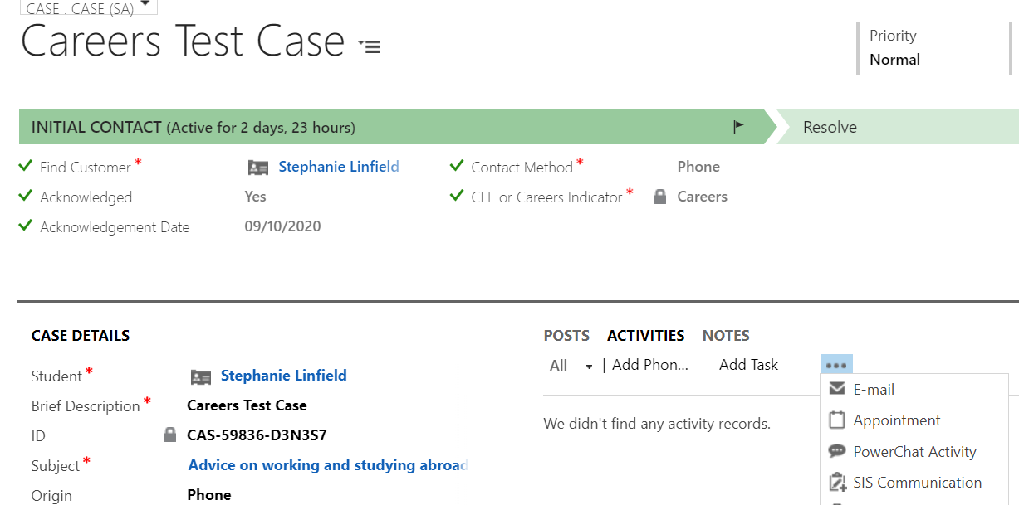

Click on **Appointment.**

This will open up the **Appointment** form:

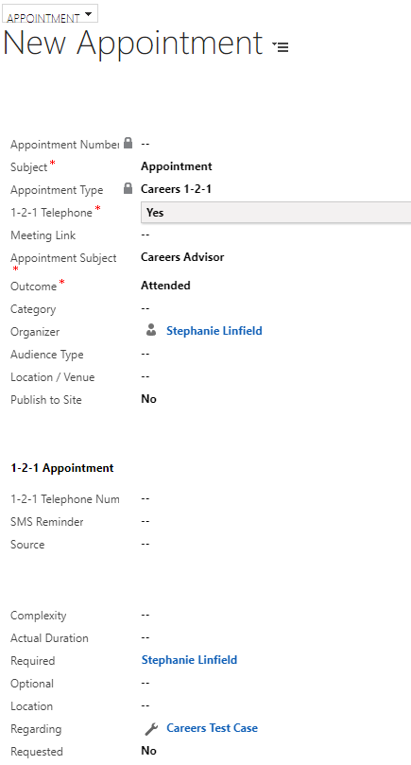

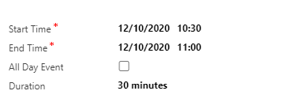

You will need to fill outthe following fields:

* **Subject** – Free text box
* **Appointment Type –** Careers 1-2-1
* **1-2-1 Telephone** – Yes or No (please note if you select No then the Location/Venue field becomes mandatory and a Room field will also appear)
* **Meeting Link** – you can add a meeting link here. Please note, for this to be an online meeting, then 1-2-1 Telephone must be set to yes, and a meeting link must be present.
* **Appointment Subject –** Careers Advisor, Employability Advisor
* **Outcome –** Attending, Attended, No-Show, Re-scheduled. You can set this to Attending prior to the appointment, but should go back into this activity following the appointment to mark whether the student attended or was a no-show etc. You must do this before marking the activity as complete.
* **Organizer –** this should default to the person setting up the appointment, but can be changed to another staff member. Click the magnifying glass to Look Up More Records, and search for the user and add.
* **Audience Type –** select the relevant one from the drop down list
* **Location/Venue –** this is only mandatory if the appointment is on site
* **Publish to Site –** Yes or No, this appointment will only appear on the website if Publish is set to yes
* **1-**2-1 Telephone number – add the contact number
* **SMS Reminder –** free text box
* **Source –** Select the relevant one from drop down list
* You may also find it useful to add the **Complexity** – select option from drop down list
* **Actual Duration** – enter time if necessary
* **Required** – this should default to the person in the case, you can add optional people and a location if necessary
* **Regarding** – this will default to the name of the Case.
* **Requested –** Yes or No
* **Start time** – enter date and time
* **End time** – enter date and time
* **All Day event –** tick box
* **Duration –** add the duration
* There is also an option to add a **Description** of what was discussed if required.

Click **Save icon (found at the top of the Appointment form) or Save and Close**

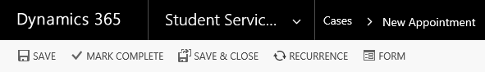

The appointment will now show within the **Activities** section of the case in the centre of the screen, along with any other activities you create.

Remember that before **Resolving** the case, you will need to **‘Complete’** all activities, including **appointments**.

***Please ensure you set the correct **Outcome** (e.g. Attended, No show etc) before closing the activity as you cannot re-open this once it is closed***

You can do this by clicking on to the activity, and clicking on the word **‘Complete’.**