**[](https://www.google.co.uk/url?sa=i&rct=j&q=&esrc=s&source=images&cd=&cad=rja&uact=8&ved=0ahUKEwjZuerSu4nXAhWGchQKHbT9CwIQjRwIBw&url=https://www.eventbrite.co.uk/o/liverpool-john-moores-university-roscoe-lectures-3233158788&psig=AOvVaw2rEDE_dQz3fMXV7J1A9n9g&ust=1508941556822069)Process Document**

**CRM – Careers**

Liverpool John Moores University

**Careers CA/EA View**

**Dashboard**

Version 0.2 February 2021

Author: DS Business Support Team

**Contents**

1. Locating Your Dashboard
2. Pinning a Dashboard
3. Views – Pop Out Function
4. Sorting
5. CA View Dashboard
6. EA View Dashboard

# Locating your Dashboard

Each Department who use CRM have their own dashboard(s), which normally acts as a ‘home’ page.

Next to Dynamics 365, there will be an Entity Name. e.g. My Work/Student Services

• Click on the downward arrow

next to Entity Name

• Select ‘Dashboards’

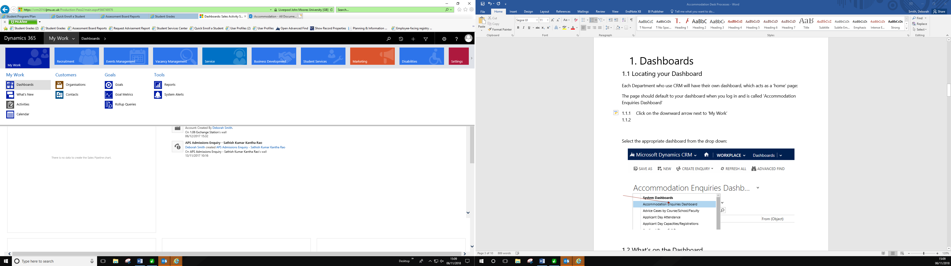

* **Select the Careers CA View or Careers EA View** from the list depending on your role

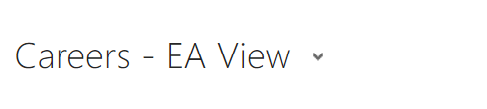

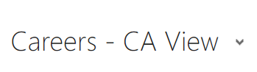

## Pinning a Dashboard

To do this, select the Dashboard, and select **‘Set as Default’**.

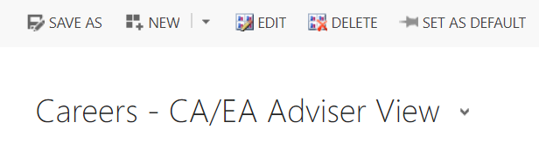

## Views - ‘Pop Out’ Function

You may find the Views within the Dashboard cut off information.

You can ‘pop out’ the view from the Dashboard by clicking on the grid button below:

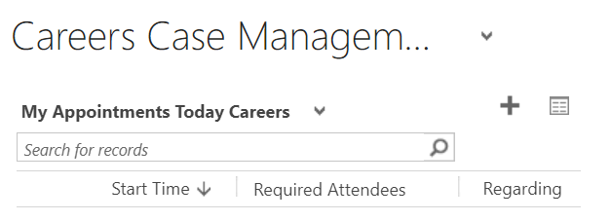

## Sorting

Remember that from within the pop out you can sort or arrange any information by clicking on the headers. You can sort (Ascending, Descending, numerical or alphabetical).

Additionally there is a Search box in the top right where you can search for a student.



# Careers CA View Dashboard

**The 6 Views are:**

1. **My Available 1-2-1 Appointments Next 12 Months**

This view will show all of YOUR available 1-2-1 Appointments that have been created in CRM.

From this view, you can click on the plus sign (+) to create a new Single Appoinment.

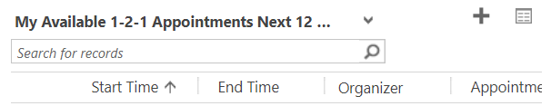

1. **My Booked 1-2-1 Appointments Next 12 Months**

This view will show all of **YOUR BOOKED** 1-2-1 Appointments. You can also view these on a Calendar view (details within the Appointments guide)

From this view, you can click on the plus sign (+) to create a new Single Appointment.

# 

# My Active Cases

Cases Owned by you that are currently open.

From this view, you can click on the plus sign (+) to create a new Case.

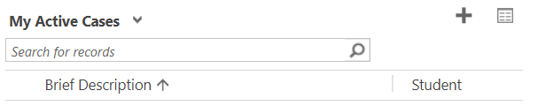

1. **My Resolved Cases**

Cases Owned by you that have been resolved (closed).

From this view, you can click on the plus sign (+) to create a new Case.

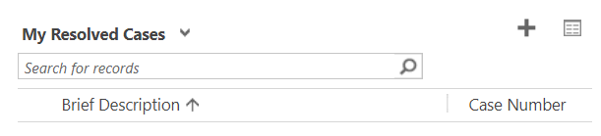

1. **My Emails Related to a Case**

This shows all Emails received that are relating to an existing record. The system has determined that the email sent in is either connected to a case or a contact record. These are still new emails that need to be processed.

If a student replies to an Email sent from a resolved case, the Email will appear here and the case will reopen.

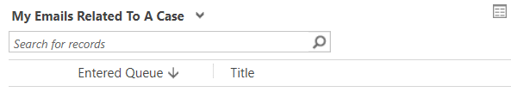

1. **My Careers/EA Emails to be Processed**

This view will show any emails that have been assigned to you that need actioning.

# 

**Careers – EA View Dashboard**

**The 6 Views are:**

1. **My Available 1-2-1 Appointments Next 12 Months**

This view will show all of YOUR available 1-2-1 Appointments that have been created in CRM.

From this view, you can click on the plus sign (+) to create a new Single Appoinment.



1. **My Booked 1-2-1 Appointments Next 12 Months**

This view will show all of **YOUR BOOKED** 1-2-1 Appointments. You can also view these on a Calendar view (details within the Appointments guide)

From this view, you can click on the plus sign (+) to create a new Single Appointment.

# 

# My Active Cases

Cases Owned by you that are currently open.

From this view, you can click on the plus sign (+) to create a new Case.



1. **My Resolved Cases**

This will be where all Resolved Cases will appear

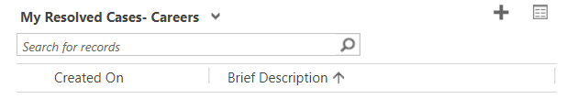

1. **My Emails Related to a Case**

This shows all Emails received that are relating to an existing record. The system has determined that the email sent in is either connected to a case. These are still new emails that need to be processed.

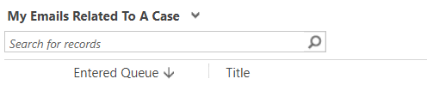

If a student replies to an Email sent from a resolved case, the Email will appear here and the case will reopen.

1. **My Careers/EA Emails to be Processed**

This view will show any emails that have been assigned to you that need actioning.

# 