# [Image result for liverpool john moores university logo](https://www.google.co.uk/url?sa=i&rct=j&q=&esrc=s&source=images&cd=&cad=rja&uact=8&ved=0ahUKEwjZuerSu4nXAhWGchQKHbT9CwIQjRwIBw&url=https://www.eventbrite.co.uk/o/liverpool-john-moores-university-roscoe-lectures-3233158788&psig=AOvVaw2rEDE_dQz3fMXV7J1A9n9g&ust=1508941556822069)Process Document

**CRM – Student Advice & Wellbeing**

Liverpool John Moores University

**Student Advice and Wellbeing**

**Referrals/Adding to Another Teams Queue**

Version 0.3 November 2018

Author: DS Business Support

**Contents**

1. **Introduction**
2. **Scenario 1:** Referring on an Email Received into the Wrong Queue
3. **Scenario 2:** Student Drop in/Phone Call with Issues for different team

**Introduction**

This guide will cover how you will refer work to other teams within CRM.

Pre Dynamics CRM, students will have been referred to other Teams within the University, by email to the other team directly, by face to face or phone referral. The students may also have either been signposted to the specific team – especially in the case of referring to Counselling – whereby the student must contact Counselling Service themselves.

In CRM, you may need to redirect emails which have been incorrectly routed to your queue, or you may need to refer students to other services/teams (who also use CRM and those who do not).

CRM does not intend to remove face to face/phone contact. However, instead of emailing/forwarding emails, you will be using CRM.The aim is to keep all information about the student in one place.

**Scenario 1: Referring on an Email Received into the Wrong Queue**

**E.g. An email received into the Advice queue, which is meant for Disability, or an email received into International Advice which is meant for International Admissions.**

**Note: If the Team do not use CRM, you should copy and paste any email details separately to send to required destination.**

**Note: Do not forward emails on within CRM by clicking on the forward button, this can cause issues for the receiving team in converting the email to a case/enquiry.**

1. Starting from your **Dashboard**. Click on to the email which has been sent to your Queue incorrectly.

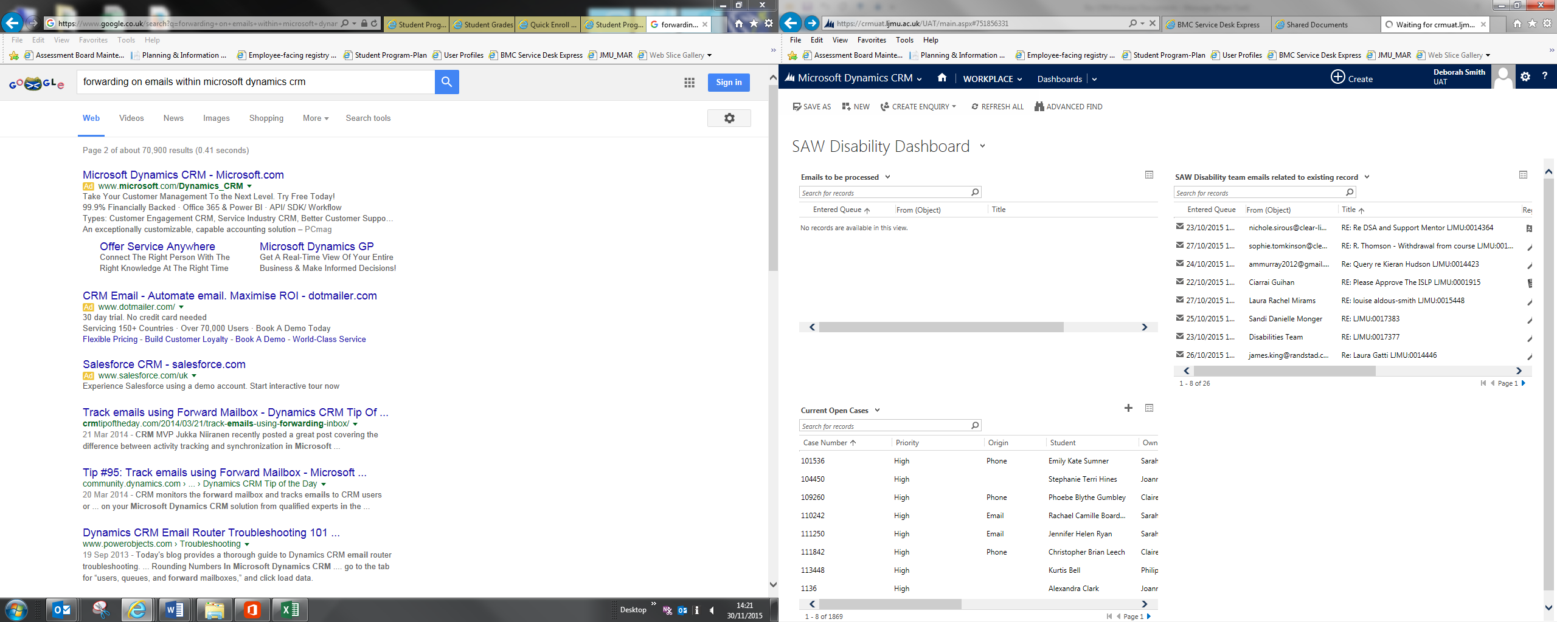

1. Once the email has opened up, click on to the elipsis (3 dots)
2. A drop down menu will appear
3. Select **Add to Queue**

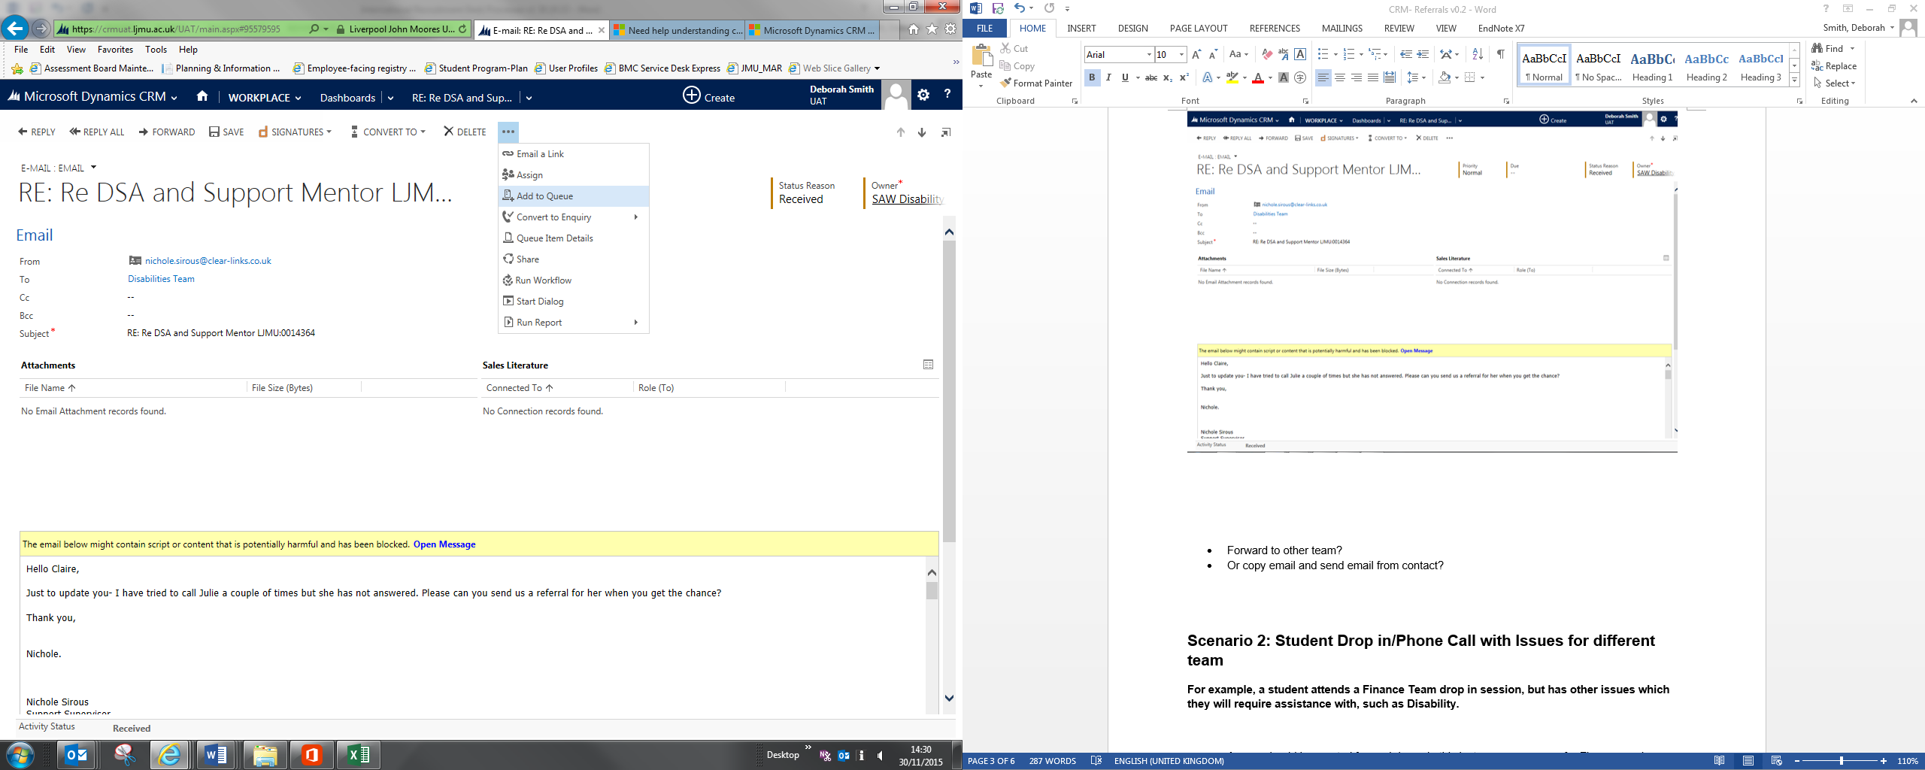

1. The **Add to Queue** window will open
2. Click into the **Queue Field** look up

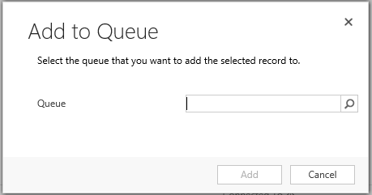

1. Ensure that you scroll down through the options to the bottom of the list.
2. Select **Look Up More Records**

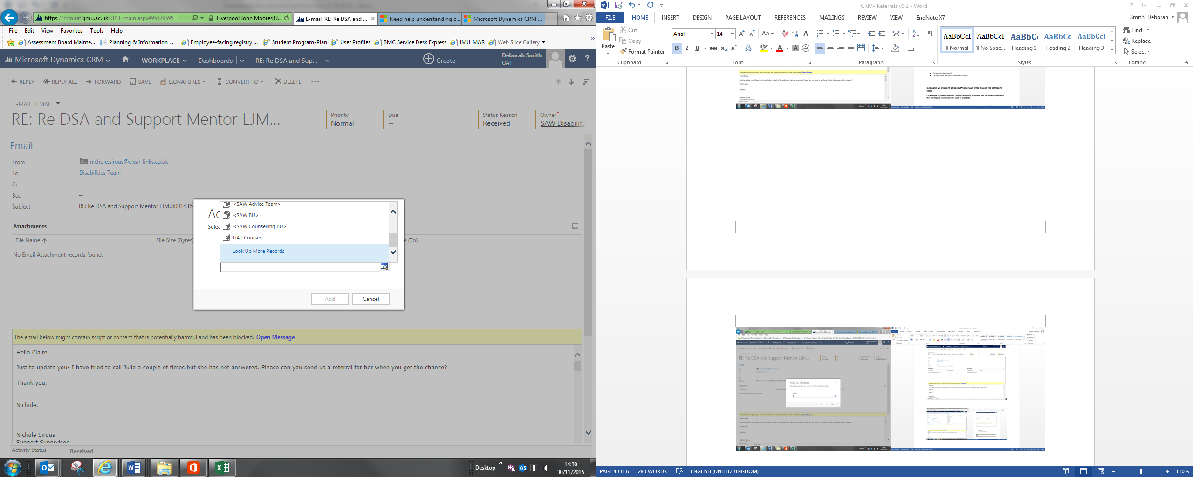

1. The **Look Up Record** window will display.
2. **Ensure that the following are completed:**

***Look For: Queue***

***Look In: Active Queues***

***Search: Search for part of the name of the queue, using a wildcard symbol * if you wish****.*

*Queues available to you to send to:*

|  |
| --- |
| **SAW Enquiries** |
| **Care Leavers** |
| **International Advice** |
| **Stay on Course** |
| **Study Support** |
| **Study Guidance** |
| **Accomodation Advice** |
| **Counselling Team** |
| **SAW Disabilities Team** |
| **Student Advice** |
| **Welfare Accomodation** |
| **Mental Health** |
| **Student Wellbeing** |
| **Student Engagement** |

***Note: Do NOT select any queues which begin with a < as these are soon to be disabled.***

1. Click on the **‘tick’** next to the queue.
2. Click **Add.**

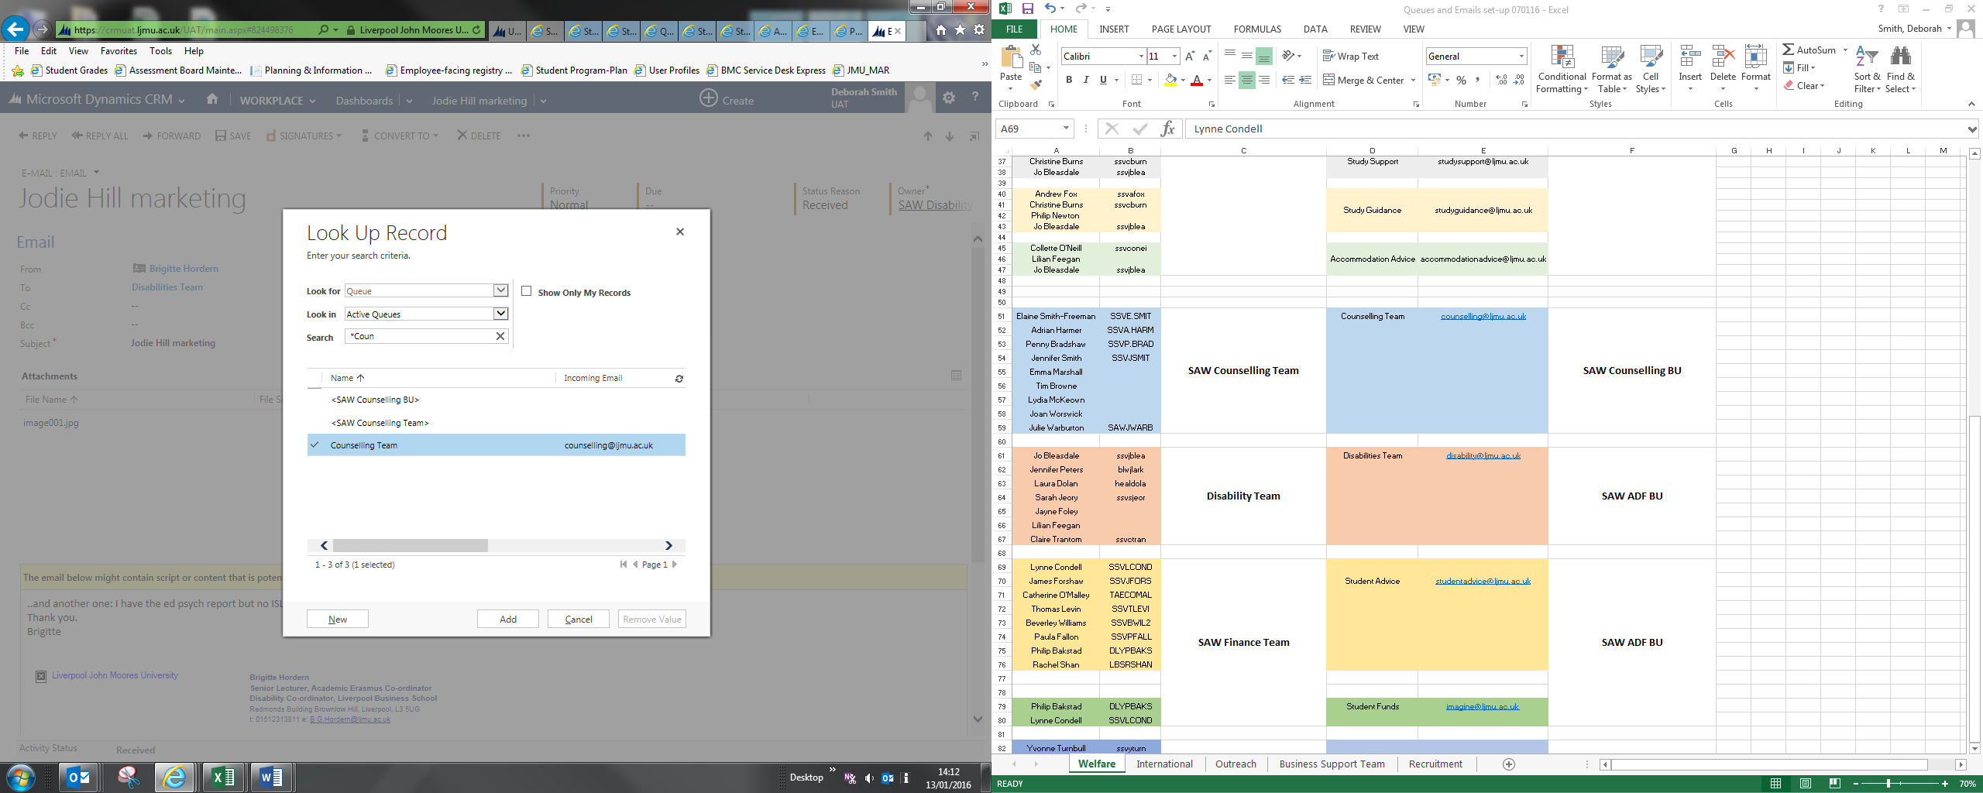

1. The **Add to Queue** box will appear, with the selected Queue highlighted.
2. Click **Add** and the Email will leave your queue and attach to the new queue.

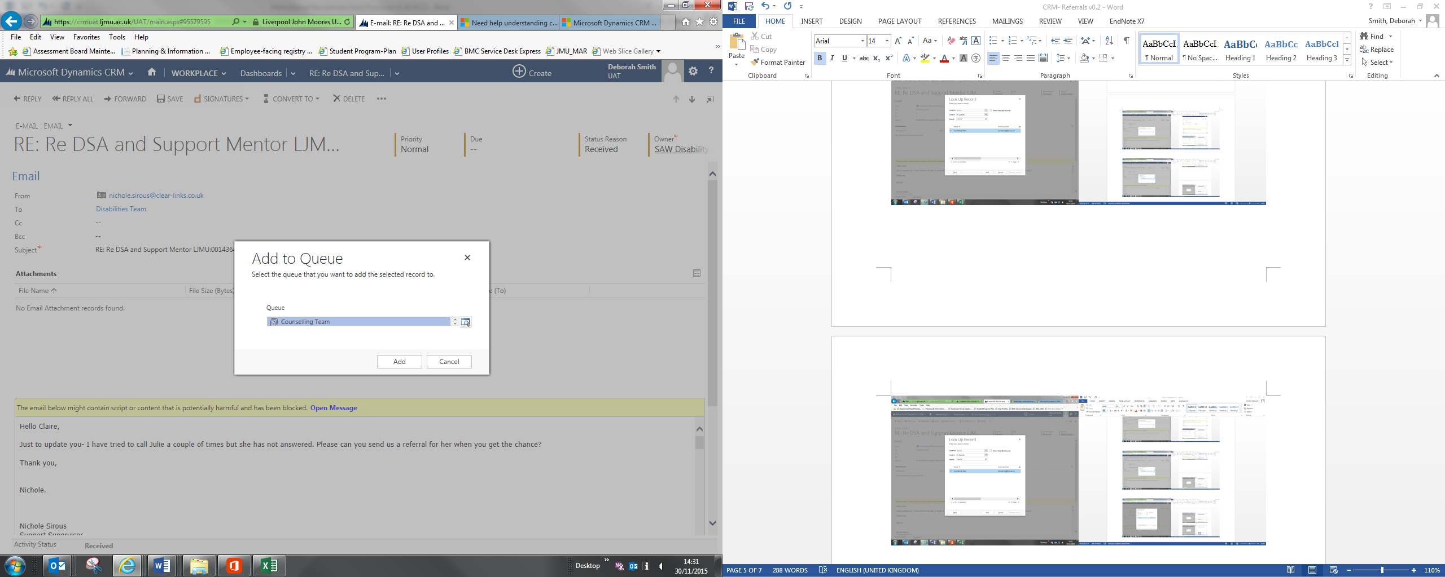

**Scenario 2: Student Drop in/Phone Call with Issues for Different Team**

**For example, a student attends a Finance Team drop in session, but has other issues which they will require assistance with, such as Disability.**

***Note: If a student has enquired regarding Counselling services, it is best practice to simply ask them to contact the Counselling team, or direct them to the Counselling Service.***

* First of all, you would create a case for the issue you can assist with. E.g. Finance.
* Then, you would email the other team e.g. Disability **from the students Contact record** with as much context and information about their issues that you have, which you believe will help the other team assist the student
* This email will then drop into the other teams queue and they can convert it into a case and deal with it accordingly.
* The advantage of doing it this way is that the ‘**Set Regarding’** will be set to the correct Contact and all information will be held against the students Contact record for continuity purposes.
  1. **Emailing from a Contact**
* Navigate to the **Contact** form
* Click on to **Activities**

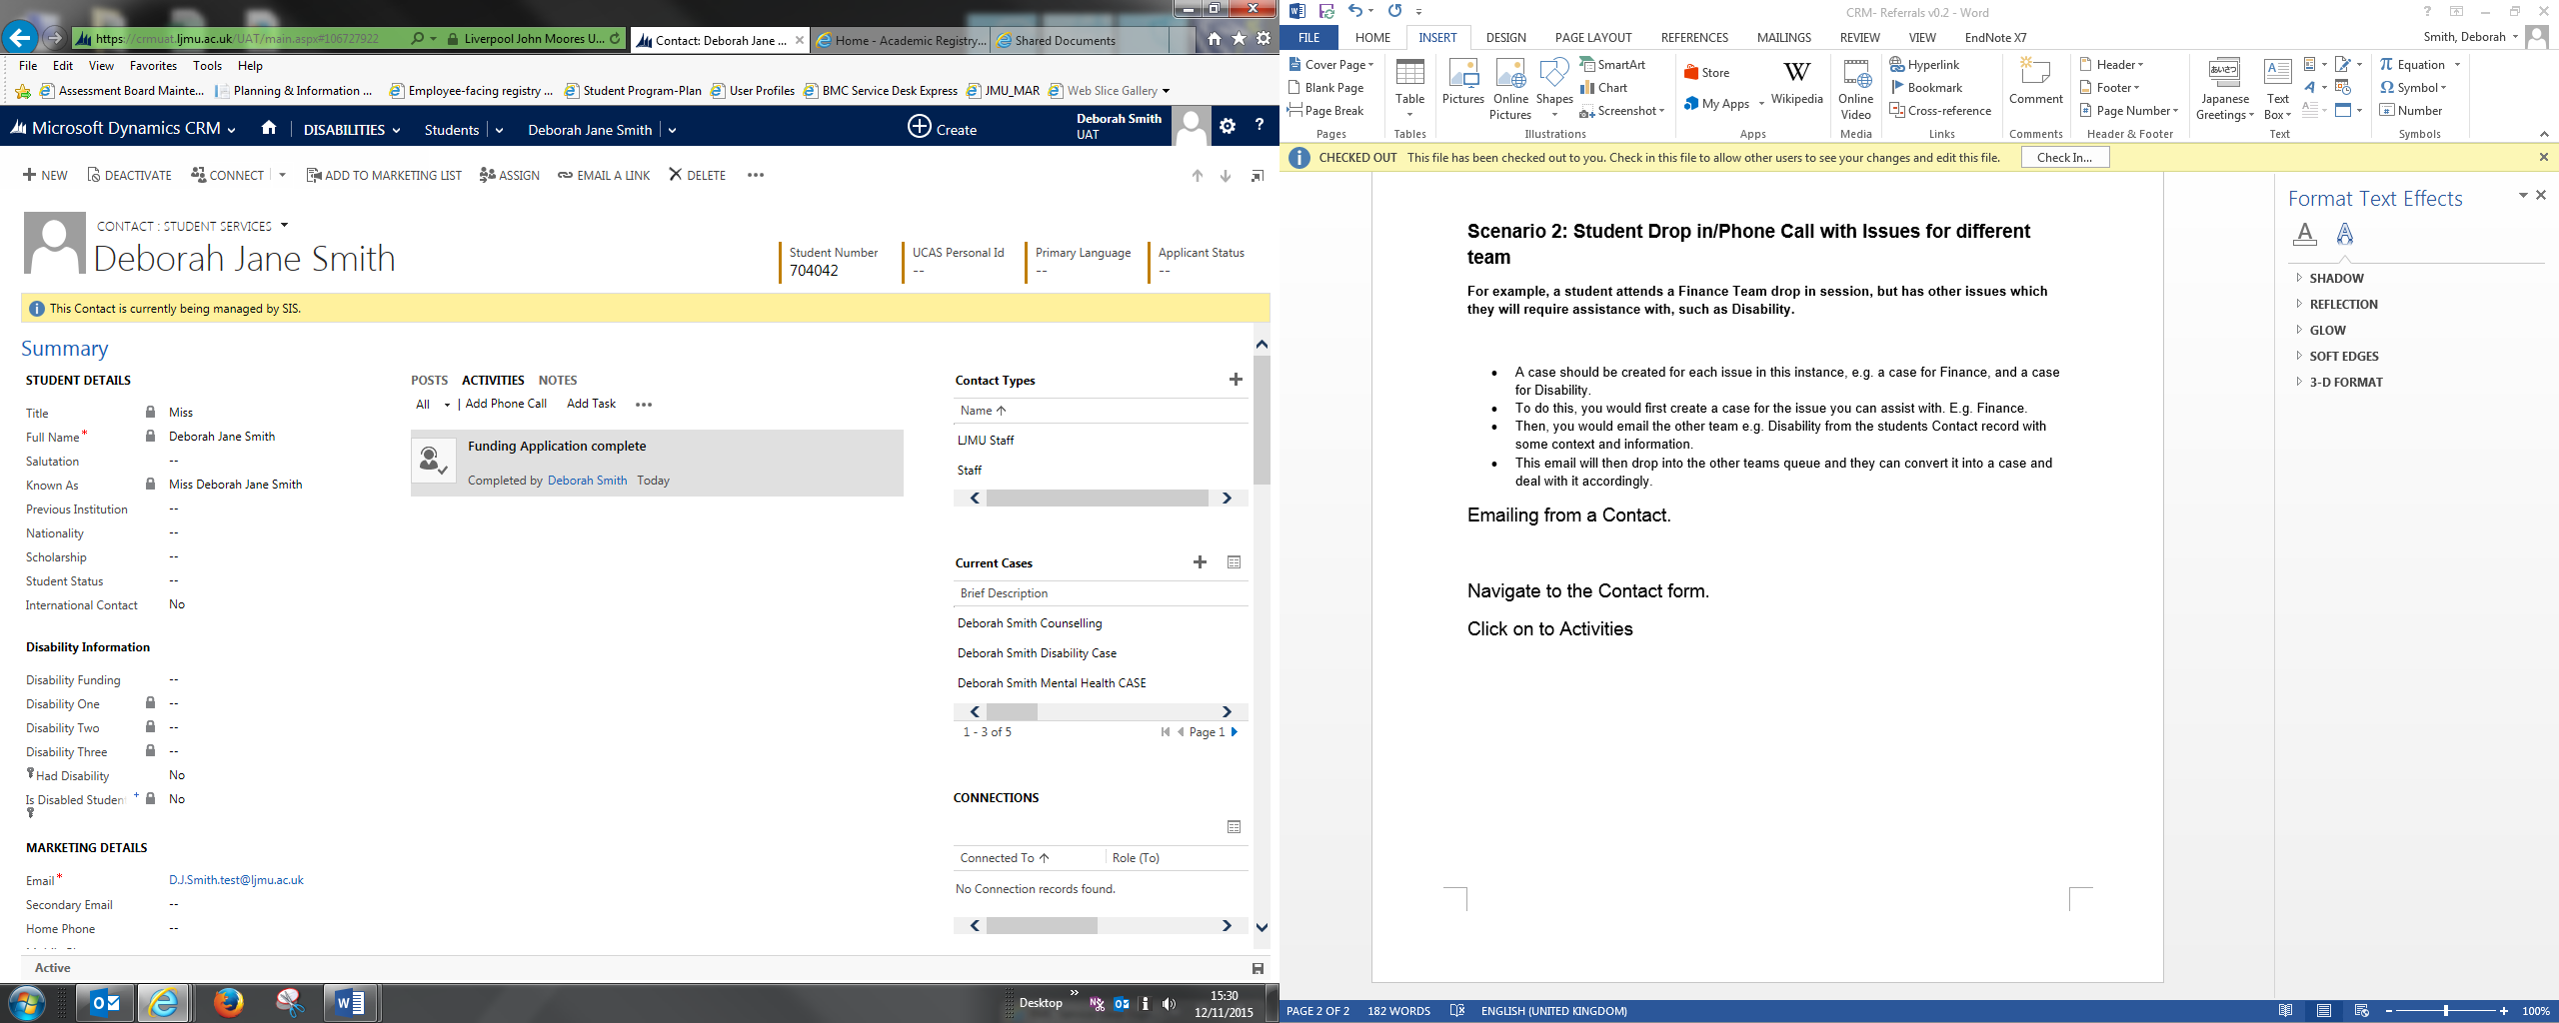

* Click on to the **ellipsis (3 dots).**
* Select **Email**

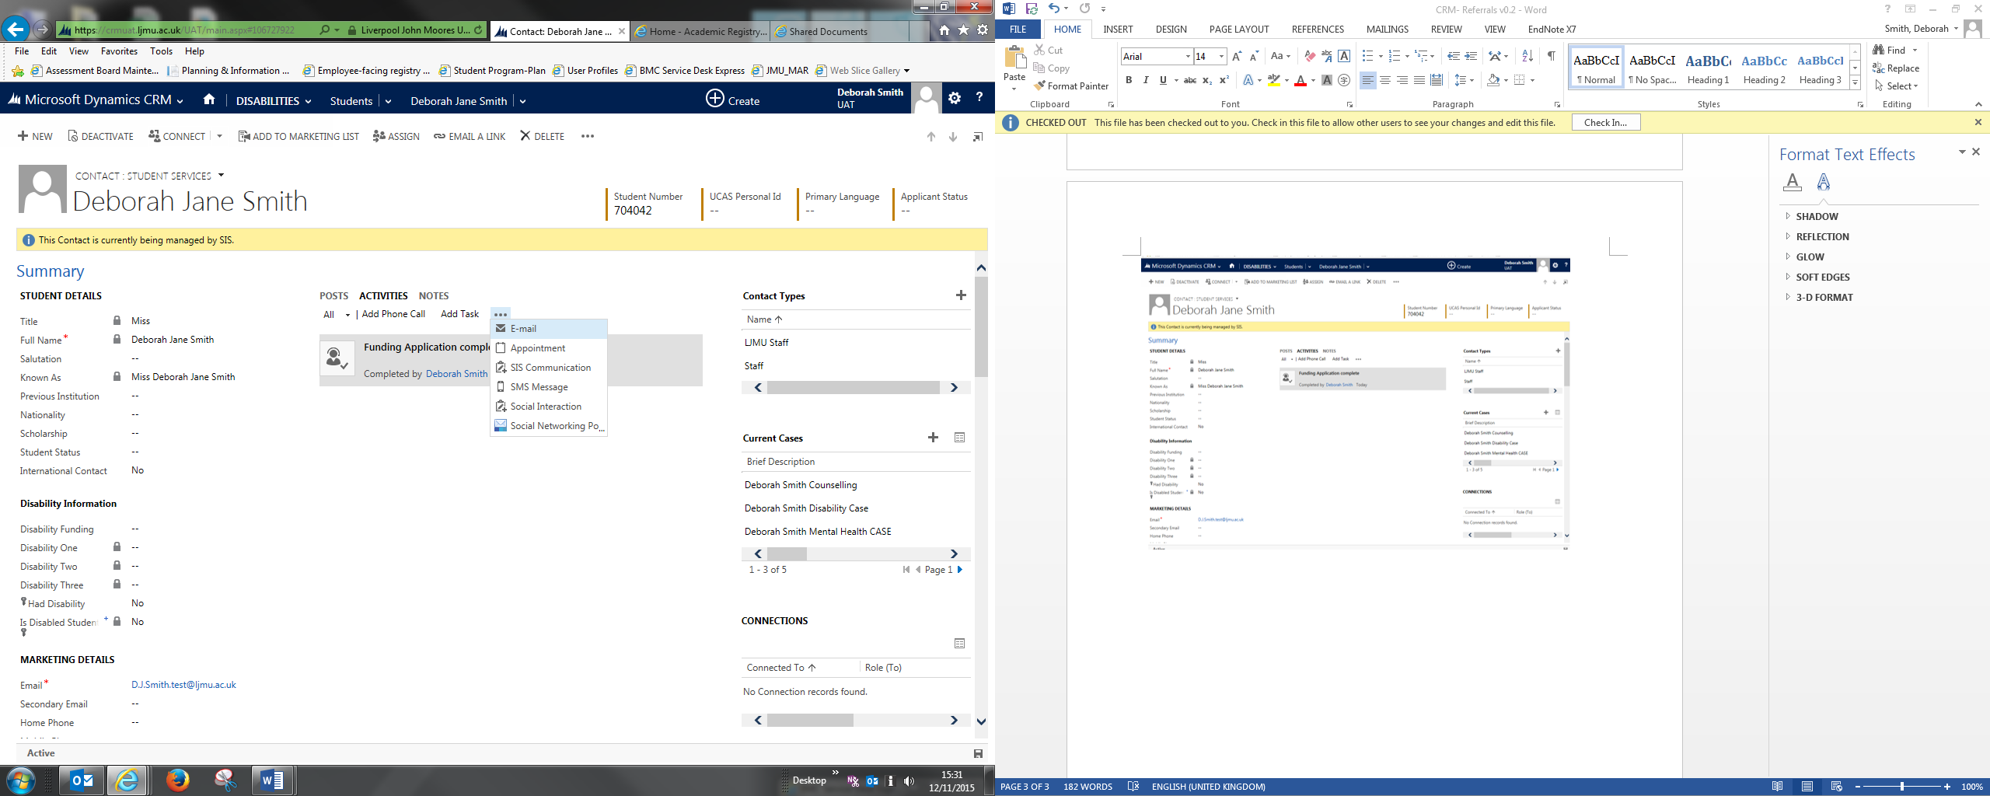

* A new Email window will open up.
* Change the **‘To’** to the correct Team
* Add a relevant **Subject**
* Include all relevant information/context in the main body of the Email
* Click **Send**

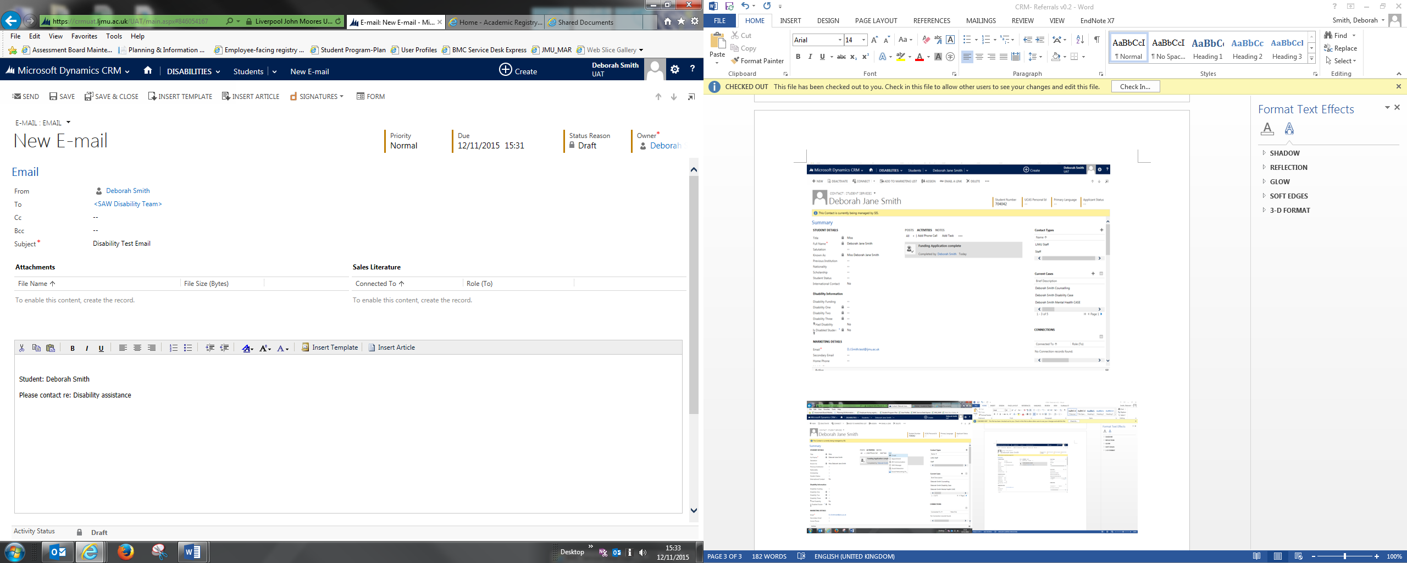

This email will then appear in the ‘**other’** teams queue and they can set up a new Case or contact the student accordingly for more information.